**anaiaha**  
 +9971

**Preetham**

[**Preetham.374597@2freemail.com**](mailto:Preetham.374597@2freemail.com)

**WORK EXPERIENCE:**

**Senior Process Executive, (Cognizant, Mangalore) May 2010 – Sep 2017** 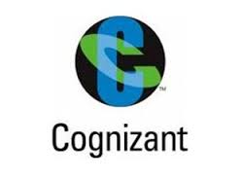

* Get in touch with U.S government taxing authorities and verify payment status for Escrow and Non Escrow accounts.
* Help team leads in planning for tax cycle management( Resource allocation / strategy planning)
* Help Team leads in preparing reports which is to be sent to clients and attend operations call on a weekly basis.
* Assist during projects related to process of my team
* Help other team members during cross Utilization
* Assist Automation team of our process whenever required and to fill knowledge gap
* Help new comer’s to understand the process and conduct training.
* US Mortgage Loan and Tax verification.
* Loan Research - Verification and updating of customer loan and tax information.
* Legal verification - Validation of property legal description.
* Pre cycle Audit - Verification of Loan information before tax payment cycle Audit.
* Worked as a SPOC & Clearing Date range orders.
* Training and Monitoring new joiners.
* QA & QC'ing the quality of production team.
* Procuring Tax amounts

**System Administrator, (Advanced Computers & Communication Services Mangalore) March 2008 – April 2010**

* Operating System: Microsoft Windows Server 2000/2003/2008/2012 Editions, Windows XP Professional, Windows 7 Professional.
* PC Assembling & Trouble Shooting,
* Remote Administration & Remote Admin Tools: Terminal Services.
* Managing users and groups, profiles and rights / Installation and Administration of Antivirus.
* Install and Configuration of Cisco Routers and Switches
* Configuring Access Lists
* Knowledge of WAN Technologies
* Configuring LAN (Local Area Networking) Internet Configuring (Dial up & Broadband), crimping network cables.
* First Level Troubleshooting.

I hereby declare that the above furnished information is true to the best of my knowledge and belief.

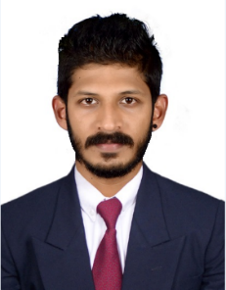

**CORE COMPETENCIES**

* BCA professional with 9+ years of expertise in customer service and System Administration.
* Data analysis by gathering customer feedback and improving customer experience.
* Hardware & Networking Certified.
* Excellent interpersonal, analytical and organizational skills.
* AllRegs Certified.

**ACADEMIC QUALIFICATION**  
 Bachelors in Computer Applications – Specialized in System Administrations.

**TECHNICAL SKILLS**

* Worked on software such as Citrix, PeopleSoft HRIS (oracle).
* Expertise in MS-Office products such as MS-Excel, MS-Outlook, MS-Word & MS-Power Point.
* Hands on experience on System administrations.

**STRENGTHS**

* Goal driven achiever where strengths include excellent planning and organization skills.
* Good managerial capabilities and the ability to work efficiently in a team.
* Good analytical ability, punctuality and sincerity.
* Adaptability and learning ability.

**ACHIEVEMENTS**

* Received “Best performer” Award at Cognizant for several times in Redemption reporting team.
* Awarded “Employee of the month” for several times at Cognizant.
* Completed AllRegs Mortgage certification.

**PERSONAL ATTRIBUTES**

* Dependable and patient
* Interpersonal Skills
* Practical

**HOBBIES**

* Riding bikes
* Listening to Music
* Travelling