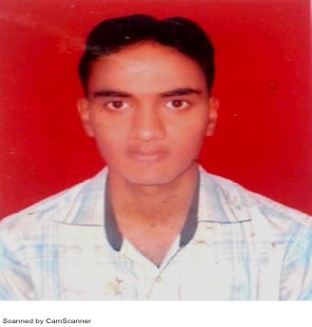

Respected Sir/Madam,

I take this opportunity to introduce myself Parthasarathi Swain as an Inter qualified Cost Accountant. Presently I am working as Cost Trainee in Food Corporation of India, District Office Bhubaneswar.

I wish to join an organization, which operates in a professional, dynamic and vibrant environment. Moreover, I am sure that there would be extremely challenging and growth oriented career opportunities existing in your organization. All this motivates me to explore an appropriate opportunity with your goodself.

On my part I can assure you that with my qualification and experience accompanied with the knowledge and skills, I would be able to make a valuable contribution to the organisation, especially in the areas of Auditing, Accounting & Taxation.

Please find enclosed herein my Curriculum Vitae for your kind perusal.

Thanking You,

Parthasarathi
Parthasarathi.374603@2freemail.com

Encl: Curriculum Vitae

Parthasarathi

COMPETENT COST TRAINEE IN THE FIELD OF AUDIT / ACCOUNTS / TAXATION

CAREER PRECIS

- Over 2 YEARS (including Cost Trainee) rich and extensive experience in Auditing, Accounts, Taxation.

AREAS OF EXCELLENCE

- Areas of Excellence:
- Internal Audit - MIS-Costing - Stock Audit - Financial Planning

SCHOLASTICS

- Completed my CMA (Inter) in Dec’2013.
- B Com from S C S (Autonomous) Collage in 2011.

EMPLOYMENT RECITAL

- Abhimanyu Nayak & Associates. (Cost trainee) From Mar’2014 to Dec-2015.
- Food Corporation of India, DO, BBSR, Odisha from Feb-2016 till date.

A SNAPSHOT OF OVER ALL RESPONSIBILITIES

Abhimanyu Nayak & Associates. (Cost trainee):- Conducting internal audits; evaluating the internal control systems with a view to highlight shortcomings & recommendations accordingly, Conducting stock audit. Cost Audit etc.

Food Corporation of India, Do, BBSR, Odisha: - Has been working in FAP module i.e. in GL, AP & AR module along with BRS and IT returns

THE ACCOUNTABILITIES

- Handling all issue related to Income Tax including TDS requirement, Income Tax Audit Report, E-filing of I.T. Return for all status of persons including for companies and personal appearance before Assessing Officer.

- Conducted internal audit on Physical Control over Fixed Assets. It involves physical verification, systems review, check of mandatory records, and suggestive actions for improvement of controls.

- Conducted audit on debtors, which involves identification and analyzing of various risk areas and implementing the suitable control.

IT SKILLS:
- Completed 100 Hrs. Of Computer Training organised by ICWAI.
- Conversant MS Office (Word, Excel & Power point),
- Working experience in Accounting Package like Tally ERP.

PERSONAL DOSSIER

Date of Birth : 06th June’1991.
Marital Status : Single.
.
Linguistic Abilities : English, Hindi, Oriya.

