CURRICULUM VITAE
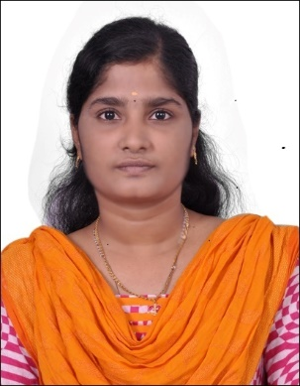
VINITA
VINITA.374615@2freemail.com

__________________________________________________________________________________________
CARRIER OBJECTIVE - REGISTERED INDIAN PHARMACIST
Seeking a career for my qualification in your esteemed organisation offer me an opportunity to explore my skills and abilities.
PROFESSIONAL QUALIFICATION
- Bachelor of Pharmacy
ACADEMIC QUALUIFICATIONS
COURSE | SCHOOL/COLLEGE | YEAR | BOARD/UNIVERSITY | PERCENTAGE
B.PHARM | Madras Medical College, Chennai | 2015 | Dr.MGR Medical University | 72%
HSC | St. Ursula’s A.I. Hr sec School, Chennai | 2011 | State board | 85%
SSLC | Assumption Hr Sec School, Chennai | 2009 | State board | 91%

PROJECT
“IN VITRO ANTI-OXIDANT SCREENING OF EXTRACTS OF Mimosa pudica
( wholeplant)

JOB TRAINING
Undergone 1month apprentice training program as a pharmacist aid in Dispensing at Rajiv Gandhi Govt Hospital, Chennai-03
WORKING EXPERIENCE
- Currently working with Apollo home healthcare Ltd as a senior Medical Administrative Integrator from Aug-2016
Responsibilities:
- Coordination with clinical and non clinical team to assign and complete targeted work.
- Follow up calls after the patient’s enrollment for feedback and payment collection
- Managing accountability
- Selling products through calls, marketing, and achieving targets
- Handling customers queries and giving suggestions.
- Selling products and marketing for business development.
- Complete process follow up
- Calls handling and providing solutions for the patients issues as per their requirements during an emergency conditions
- Entering patient details in prospect and maintaining documentation in EMR.
- Dealing with medical equipment lead generation and delivery of the equipment
- Preparation of monthly review reports based on analysis in the aspect of business development
AWARDS:
- Received an award for more number of calls handling and conquered or limited patients issues by sorting out in immediate manner/ response
- Received an award for good performer of the month.
HISTORY OF WORK EXPERINCE:
Designation:
- Worked with AJUBA as a medical coder in the field of medical coding for about 1 year of experience from Sep 2015 to July 2016. Dealing with Anesthesia Business Consultant (ABC) project as a facility coder.
Responsibilities:
- Providing Healthcare Revenue Cycle Outsourcing for clients in the US.
- Receiving patient’s case sheet or charts which contains all provided informations about the patient’s diagnosis, treatment given and procedures performed.
- After receiving all the charts, the universal codes will be given to each and every diagnosis and procedures that were performed to that patient.
- Then the completed charts will be sent to the billing department, once the billing is finished, the billed charts will be sent to the clients for claiming the insurance.
AREA OF INTEREST
- Pharmacist/ Chemist
- Medical coding (Non Voice)
- Healthcare related – customer service

PERSONAL SKILLS
- Willingness to learn and work in team
- Good knowledge in medical terminology
- Leadership, MS Outlook, MS Word, MS Power point
- Good communication skills
- Good knowledge in MS Office
- Good Typing knowledge
PERSONAL PROFILE
Date of Birth : 06-10-1993
Gender : Female
Marital status : Married
Nationality : Indian
Languages known : English & Tamil
DECLARATION
I hereby declare that the details furnished above are true and fair to the best of my knowledge.

Place: Chennai Signature
Date: 13.11.2017

