Mahathir Mahathir.374626@2freemail.com
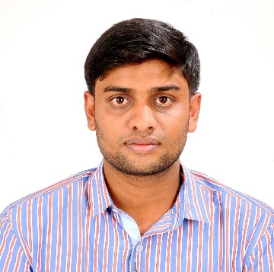
About Me
2 Years 6 months experience experience
November 13, 1992
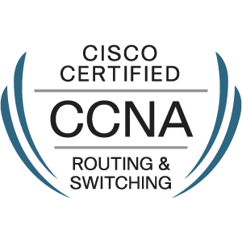
Dubai, UAE

Career Objective
To be part of a dynamic organization with a professional work environment, while contributing to the growth of the organization and advancing my career.
Work Experience

System Engineer
Feb 2016 – Apr 2017
Precision infomatic (M) Pvt Ltd – Chennai
Desktop Support Engineer
Oct 2014 – Dec 2015
K.G.K Computers Pvt Ltd – Thiruvarur
Job Responsibilities

- Installation and configuration of Windows based operating systems
- Trouble shoot all types of hardware and software application problems
- Setting up new user accounts & profiles & dealing with password issues.
- Create and manage AD ID
- Provide database connection
- Configure & troubleshoot printer, scanner & LAN related issues reported by users
- Configure VPN client setup on user’s laptop
- Create and manage FTP
- Monitor any virus issues through McAfee Endpoint Protection antivirus
- McAfee patch updating, encryption and decryption for laptops
- Checklist Maintenances Activity
- Configure and trouble-shoot Mail Client Lotus Notes
- Create and manage Biometric ID
- User profile backup and restoration
- Provide remote support to the user to troubleshoot
- Basic Networking Mapping Drive, share folder access and permissions
- Asset Inventory Management
- Installation and configuration of VM ware image
- Software update and patch installation
- Resolve tickets within the SLA raised by end users
Technical Skills

- Configure Routing Protocols (RIP, EIGRP, OSPF)
- Dynamic Host Configuration Protocol (DHCP)
- Network Operation and Maintenance (Router CLI: Configuring & troubleshooting)
- Configure V-LAN, Inter V-Lan Routing
- Network Addressing (IP Subnet Mask & Gateways)
- Configure LAN Network (Ethernet Switching)
- Network Security (ACL) STD ACL, EXT ACL
- Network Address Translation (Static, Dynamic, Dynamic with Overload [PAT])
- Knowledge of HSRP and DNS
- Active directory user account administration
Professional Qualifications

CISCO Certified Network Associate(CCNA)
Education

B. Tech Information Technology Graduated, April 2014
Anna University
Personal Details

Gender: Male
Marital Status: Single
Nationality: Indian
Languages: English, Tamil
Visa Status: Visit Visa (Valid till 02-jan-2018)
Declaration
I, hereby declare that the information is true and correct to the best of my knowledge
____________________________

