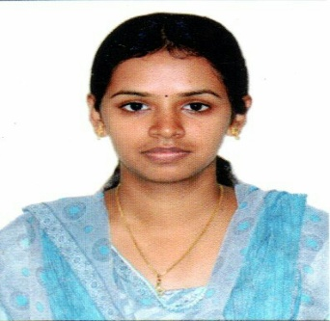
Sharjah, UAE
Email : deepika.374661@2freemail.com
Deepika
HR Executive
1.6 years experienced HR with good communication and decision making skills, looking for challenging career. I am now looking, after a short professional break, to pursue a highly rewarding position in a competitive and healthy work environment.

Professional Experience | - Conduct end-to-end recruitment activities from identifying vacancies, receiving employment requests from clients to interviewing, short-listing and selecting candidates to on-boarding and induction program  - Acts as a vital links between candidate and the client company  - use social media and job sites to advertise vacancies, attract candidates and build relationships with candidates and employers  - HEADHUNTING - identifying and approaching suitable candidates who may already be in work, using candidate databases to match the right person to the client's vacancy  - receiving and reviewing applications, shadowing interviews and tests of candidates  - Preparing CVs and correspondence to forward to clients regarding of suitable applicants  - briefing the candidate about the responsibilities, salary and benefits of the job in question  - receiving feedback from the client about the performance of the candidates post interview  - working towards the targets that may relate to the number of candidates placed, a value to be billed to clients  - Developing a good understanding of client companies, their industry, what they do, plus their work culture and environment  - In case of immediate requirement for a vacancy, arranging for telephonic interviewing or Skype interview for the candidate  - Cold calling the candidates information about the vacancy and enquiring their interest in that position  - Knowledge of payroll processing  - Attendance management  - Training & Development  - Helping the candidates with any queries post recruitment till the orientation  - Reporting the number of cold calls made to the suitable candidates, the number of candidate who attended the interviews and the number of No Show candidates, to the Manager  - Maintaining record of the candidate for future references  - Maintaining the record of the vacancies provided from the clients, number of the candidates who have been given Interview call letter, candidates who attended the interviews and the candidates who have been selected
Skills | PERSONAL  Decision making  Communication  Team player  Leadership abilty  TECHNICAL  BEC (Prelim)  C, C++  Resource Pooling  MS Office  Application Tracking system(ATS)  Payroll Management
Work History | CONSIGN SOLUTIONS – COIMBATORE, INDIA MAY, 2K15– NOV,2K16  Technical HR
Education | SATHYABAMA UNIVERSITY – CHENNAI, INDIA 2013-2015  M.E in Embedded systems, 8.1 (CGPA)  VEL TECH MUTLI TECH COLLEGE – CHENNAI, INDIA 2009-2013  B.E in Bio Medical Engineering, 7.9 (CGPA)

Interests | Reading books
 | Social Medias – Facebook, Twitter, LinkedIn, Pinterest, Instagram
 | Gardening
 | Watching movies

Details
Nationality : Indian
Age : 25
Notice Period : None

