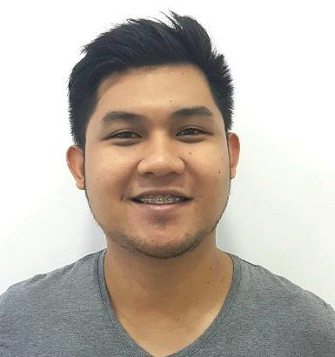
Marc
E-mail Address: marc.374675@2freemail.com

OBJECTIVE
Wish to apply as a Physiotherapist in your respected institution where I could be able to apply my learned knowledge as well as to develop my skills and to learn new trends in physical therapy profession.

YEARS OF EXPERIENCE: 6 years

UAE EXPERIENCE:
August 4, 2015 – August 3, 2017
- Health and Beauty Polyclinic, LLC
- Physiotherapist Staff
- Al Muwaiji, Near Al Ain Hospital, Al Ain City, Abu Dhabi, UAE

CLINICAL/PROFESSIONAL EXPERIENCE:
September 2013 – April 2015
- Aventus Medical Care, Inc. – Makati Branch
  - Physical therapist staff
  - 6F Filomena Bldg., Salcedo Village, Makati City, Philippines
January 2013 – August 2013
- Body Central Physical Therapy Clinic (Sports & Orthopedic Rehabilitation)
  - Private practice – Physical therapist staff
  - 19 V. Luna Road, corner Matatag St., Quezon City, Philippines
July – October 2012
- Cardinal Santos Medical Center (Rehabilitation Department)
  - Physical Therapist
  - 10 Wilson St. Greenhills West, San Juan City, Metro Manila, Philippines
January – June 2012
- The Medical City (Physical Medicine & Rehabilitation)
  - Physical Therapist Staff
  - Ortigas Avenue, Ugong, Pasig City, Metro Manila, Philippines

September – October 2011 and October 2012 – December 2012
- De Los Santos Medical Center (Physical Therapy & Rehabilitation)
  - Physical Therapist – Auxiliary Staff
  - 201 E. Rodriguez Sr. Blvd, Quezon City, Metro Manila, Philippines

LICENSURE/CERTIFICATES/SEMINARS:

HAAD License No.: GT18704
Licensed As: Physiotherapist 1
Issue Date: Dec 13, 2015
Expiry Date: Dec 13, 2017

July 2011 – Licensure Examination for Physical Therapists/Occupational Therapists
(Professional Regulatory Commission) – Philippines
General Average: 81.55%
Remarks: Passed
License no. 23483

4th Neuroscience Updates Congress
Held at Jumeirah Hotel at Etihad Towers, Abu Dhabi on 3rd June 2016

Infection Control Seminar
Held at Nightingale Home Health Care, Al Ain City, Abu Dhabi on 21st October 2016

Basic Training Course: InMotion Arm, Hand and Wrist Robot (16 hours)
Held at Cardinal Santos Medical Center on August 13, 2013

2008 PPTA Annual Convention: “Improving Physical Therapy thru Lifelong Learning”
Held at Traders Hotel on September 20-21, 2008

“Career Path for Physical Therapists in the Philippines and Abroad”
Held at National Tobacco Administration Auditorium, City of Batac, Ilocos Norte on August 19, 2005

QUALIFICATIONS/SKILLS:
- Hardworking and energetic; flexible; careful; team player where I can work with my co-workers harmoniously; willing to learn
- Computer literate
- Can speak basic Arabic commands/instructions
- Performs evaluations, re-avaluation & treatment of various neurological, orthopedic, pediatric & musculoskeletal conditions
- Modalities: Uses a variety of physical agents such as CPM machine, hubbard tank, hydrotherapy, cryotherapy, TENS, whirlpool, muscle stimulation, biofeedback, ultrasound, hot/cold packs, ergometer, graded weights, etc.
- Basic knowledge/utilization in kinesiotaping on various musculoskeletal condition
- Utilizes appropriately the assistive devices, orthopedic & prosthetic devices

PERSONAL INFORMATION

Religion Christian Birth date December 22, 1988
Birthplace City of Batac Civil Status Married
Age 28 Height 5’8 ft.
Weight 80 kg.

I hereby certify that the above information is true and correct to the best of my knowledge.

MARC
Applicant

