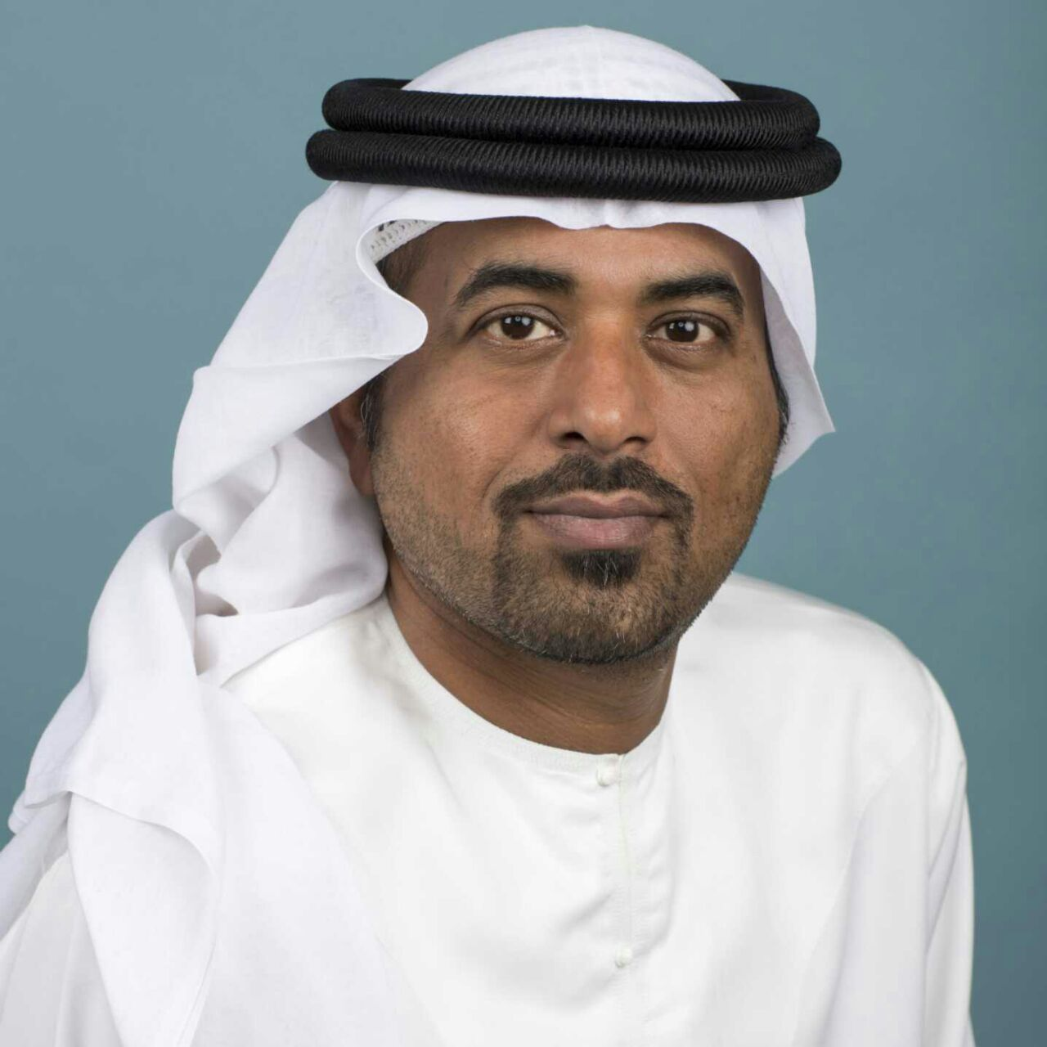
Mubarak.374683@2freemail.com
Mubarak

SENIOR MANAGERIAL ASSIGNMENTS
CONSTRUCTION MANAGEMENT | PROJECT MANAGEMENT | CONTRACTS MANAGEMMENT | FACILITIES MANAGEMENT
A versatile, high-energy professional with merit of executing prestigious projects of large magnitude within strict time schedule, cost & quality
Industry Preference: Real Estate / Construction ~ Location Preference: UAE

Key Skills | Profile Summary  - Offering over 24 years of experience in Strategic Planning for Project Milestone, Contracts Administration, Resource Planning, Budgeting & Forecasting, Training & Development and Manpower Leadership  - Exhibited excellence in executing various offshore Oil & Gas projects, buildings, steel structures, roads, pipelines and underground services  - Incisive acumen in improving supplier operational performance and reduced costs, higher quality & improved lead times through Capex Optimization, FIDIC Contracts and Process based Procurements  - Experience in monitoring project activities from conceptualization to execution including technical specifications, stage inspections & progress monitoring and ensuring on-time closures within preset cost parameters  - Led implementation teams in numerous projects in diverse environments  - Addressed HR requirements with qualified staff in different disciplines from different parts of the world through, screening, interviewing, verifying credentials  - Knowledge of AutoCAD, SAP, Primavera and ACONEX  - Excellent relationship management, analytical and negotiation skills with capabilities in swiftly ramping-up projects in coordination with clients, contractors, vendors and consultants  Education  - Bachelors in Civil Engineering from UAE University, Al Ain in 1992
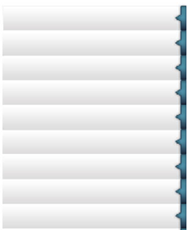
Contract / Construction Management

Strategic Project Planning / Plant Layout Designing

Site Engineering

Technical Documentation

Resource Optimization

Cost Control

Risk Assessment & Safety

SAP-R/3

Condition Monitoring: Quality & Safety

IT Skills

- MS Project, MS Office Suite (Word, Excel, PowerPoint & Access), SAP, AutoCAD, Primavera and ACONEX

Career Timeline
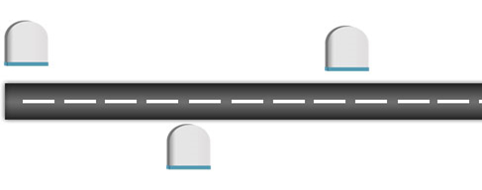
2008-Present
ALDAR Properties PJSC as Project Director
1992-2007
Abu Dhabi Gas Liquefaction Company (ADGAS), Das Island as Head of General and Technical Services
2007-2008
Dubai Cable Private Company LLC (DUCAB), Jabel Ali as Project Manager – Civil
Soft Skills
Planner
Motivator
Communicator
Collaborator
Change Agent
Work Experience

Since Jun’08 with ALDAR Properties PJSC as Project Director – International Projects

Nov’07 – Apr’08 with Dubai Cable Private Company LLC (DUCAB), Jable Ali as Project Manager – Civil
(New Special Cable Unit Factory)

Dec’92 – Apr07 with Abu Dhabi Gas Liquefaction Company (ADGAS), Das Island as Head of General and Technical Services

Role:
- Developing contracting strategies; performing analysis of technical & commercial aspects of the offers; controlling contracts in terms of deviations at execution stage; ensuring effective business planning & control to maintain financial integrity of projects
- Providing strategic & technical inputs on methodologies of construction including field engineering support; sequencing, monitoring, planning, reporting and controlling the engineering, procurement & construction activities
- Strategizing short / long-term action plans regarding the business growth, project management, O&M and development as part of the executive decision-making team
- Administering array of project operations such as planning & scheduling, resource allocation, project accounting and control, while providing technical direction and ensuring compliance with quality standards
- Formulating project baselines; monitoring & controlling projects with respect to cost, resource deployment, time overruns and quality compliance for ensuring satisfactory execution of projects
- Establishing processes & SOPs and deploying various methodologies & recommending modern practices to save execution time, minimize bottlenecks, realize operational efficiencies, control cost & reduce cycle time
- Preparing budgets & analyzing variances between projected & actual costs; implementing corrective actions for rectifying the same
- Liaising with consultants, contractors, team members & other officials for ensuring effectiveness of site activities, discerning and managing risks present in the projects, as well as planning for contingencies
- Reviewing quality at project site by exercising rigorous quality control plan & procedures
- Extending support for development of master schedules, resource schedules, execution plans, budgets, statement of requirements, project close-out reports, QHSE management plans and tenders
- Mapping training needs and conducting technical & non-technical development activities for the department’s existing staff
- Conducting:
- Advance Safety Audits (ASA)
- Safety Workshops
- Near - Miss Reporting
- HSE Workplace Committee Meetings
- Management Safety Tours
- Active member in Task Risk Assessment Committee (TRA)
- Process owner of HSEMS (HSE Management System)
- Process owner of AIRMS (Integrity and Reliability Management System)

Significant Accomplishments:
At ALDAR Properties PJSC
- AL Muneera Project – saving over AED 500 million via Competitive tendering, value engineering and renegotiation the subcontractor packages
- AL Falah Project – saving over AED one billion via Competitive tendering, value engineering and renegotiation the subcontractor packages
- AD Plaza Project - Thirty Million Man-hours (30,000,000) without any lost time injury achievement on 9 March 2016

At Dubai Cable Private Company LLC (DUCAB)
- Successfully issued DUCAB’s first Complete Contract Document for bidding with complete tendering and evaluation systems
- Completed a gas based auxiliary power supply for a major project (10 MVA) which equated to a potential savings of 16 Million AED to which DUCAB has decided to implement the suggestion

At Abu Dhabi Gas Liquefaction Company (ADGAS)
- Achieved target consistently for 7 years without Lost Time Incident with ADGAS from 2000 – 2007
- Conferred with:
- Certificate of Excellence for “The Movement to the New ADGAS Das Main Office Building” by Plant Maintenance Engineering Manager in January 2002
- Certificate of Excellence for “Man of the Year” by Plant Maintenance & Engineering Manager in September 2002
- Certificate of Excellence for “The Replacement of the Loading Arms” by Plant Manager in December 2002
- Certificate of Exceptional Performance for “Innovative Work in Identifying Business Improvement” by General Manager in 2004
- Certificate of Recognition for “Contribution and Support to Competence Assurance Management System (CAMS) Implementation” by Production Manager in December 2005
- Certificate of Recognition for “Excellent Contribution ad Support in Modifying and Renovation the Fishing Club” by Fishing Club Chairmen in May 2006
- Spot Recognition Award for “Production Division Performance Achievement” by Production Manager in December 2006
- Spot Recognition Award for “The Valuable Contribution towards the Successful Implementation of the Redeveloped HSE Management System” by Integrity and Quality Manager in December 2006
- Spot Recognition Awards for “Continuous Support and Contribution to the Successful Conduct of the AIRMS Sub-committee and its Progress” by Production Manager in January 2007

Projects

At ALDAR Properties PJSC
Project Title: Abu Dhabi Plaza, Kazakhstan
Client: Crown Prince Court – CPC
Project Value: US$ 1.3 billion
Designation: Managing Director
Period: Jul’15 - Present
Description: The Abu Dhabi Plaza Complex, is developed by Aldar, will be ready by July 2017 in Astana, to be ready for the Economic Expo 2017, which will be held in Astana, the capital of Kazakhstan.
The Abu Dhabi Plaza Complex project will include 90,000m² of commercial space, 598 residential units in a 75 storey tower (382 meter) , the highest tower in Central Asia., a retail space of 111,000 m² and two 390 rooms’ hotels.

Project Title: Abu Dhabi World Trade Centre
Client : Crown Prince Court -CPC
Project Value: AED 6.7 Billion
Period: Jun’13 – Jul’15
Description: A fully integrated mixed-use development comprised of grade A offices tower (72,000m²), 95 storey residences tower (80,000m²), mall (60,000m²), souk and 195 rooms hotel Courtyard by Marriott, the site of WTC holds a special place in the capital's history as the location of the old Central Market – a 12-acre single-story market that was the center of all business and trading in the growing city.

Project Title: Al Falah Community Development
Client : Crown Prince Court –CPC
Designation: Senior Project Manager
Project Value: AED 9.3 billion
Period: Jun’12 – Jul’15
Description: Al Falah community is a master planned development area which occupies a 12.5 million square meter area, located on the east of the Abu Dhabi International Airport and Abu Dhabi-Dubai highway. It has been designed to provide full community facilities and extensive opportunities for UAE National citizens.
Al Falah consists of five 'villages' presenting 4,857 villas and a range of community amenities. Each of the five villages is arranged around its own landscaped “Village and Neighborhood Centers’ and will contain a mosque, market square as well as mix of local shops and offices. To ensure convenience of residents all shopping facilities are strategically placed within a 10 minute walk from all villas.

Project Title: Al Muneera Project
Client : ALDAR Properties
Designation: Senior Project Manager
Project Value: AED 3.2 Billion
Period: Jun’08 – Jun’12
Highlights:
- Managed the construction of AL Muneera Project within Al Raha Beach Development
Islands:  - Residential Towers (10 nos.) 14 floors  - Townhouses (64 units)  - Villas (11 units)  - Retail (22 units) | Mainland:  - Residential Towers (6 nos.) 14 floors  - Commercial Tower (1 no ) 12 floors  - Townhouses (84 units  - Retail (3 units)

At Dubai Cable Private Company LLC (DUCAB)
Project Title: Construction of the New Special Cable Unit Factory in Jable Ali Area (AED 400 Million)
Role:
- Conducted project feasibility study with defined options and provided final recommendations
- Managed preparation of tender enquiry and contract documents to FIDIC and value engineering principles

Abu Dhabi Das Liquefaction Company (ADGAS)
Head of General & Technical Services
Roles & Responsibilities: Accountable for the overall contract performance of strategically outsourced hard and soft services
And responsible for delivering effectively outcomes that meet the objectives of its critical stakeholders.
- Effectively and efficiently plan, direct and manage the mobilization of facilities management outsourcing across all entities of the business, ramping up to full operation within defined timescales and parameters.
- Accountable for the ongoing Direction, development and Management of contractors in the successful delivery of a full complement of hard and soft services, ensuring adherence to contracted KPI and SLA.
- Develop and maintain high level maintenance plans, ensuring contractor’s ability to accurately and effectively meet all timelines whilst delivering the highest quality standards and value for money.
- Ensure contractor’s effectiveness in developing, managing and maintaining appropriate technical / operational standards and quality assurance processes
- Establishing and implement controls and risk management targeted at increasing operational/cost efficiency, improve management information, ensure compliance, improve/standardize service delivery, increase internal/external customer satisfaction.
- Promote and maintain the highest standards of Health, Safety & Environmental Management and ethical employment and treatment of internal and contracted workforce.
- Monitor and direct daily operations to ensure that goals and objectives are met in term of service
- Deliver and align annual strategy plans relating to outsourced services with the organizations overall operating strategy.
- Accountable for the development, management and reporting of budgets relating to facilities management activities
- Maintain contractual records and documentation and control of all contract correspondence, information sheets, status reports and other documents for all activity streams.
- Monitor contractors’ compliance with established procedures, fair labor standards and general welfare, identifying areas of risk / breach applying appropriate corrective actions in remedy.

Trainings

- Attended various seminars, exhibitions, conferences, and in-house courses, including:
- Modern Management Techniques, Project Management, Finance for Non-Financial Staff, Networking
- SAP/R3 Enterprise System, Advance Management Techniques
- Safety Industrial Plants, Writing Project Specifications, Problem Solving & Decision Making, Contract Administration, Effective Budgeting and Cost Control, Skills Analysis & Competency Profiling, Environmental Awareness
- Introduction to Management, Contract Strategic Management
- Time Management, Meeting Skills and Team Building, Team Building & Leadership Skills
- Introduction to Contract Management, Total Value Engineering, Risk Management, Self-Management, Waste Management, Risk Assessment Training, Maintenance Management, Mobilizing People (IMD)
- Balance Scorecard Concepts and Process

Personal Details

Date of Birth: 24th December 1968
Languages Known: Arabic & English
Address: Abu Dhabi
Visa Details: UAE Citizen
Nationality: United Arab Emirates
Marital Status: Single

No. of Dependents: 0
Passport Details: Y4F580543
Driving License Details: UAE

