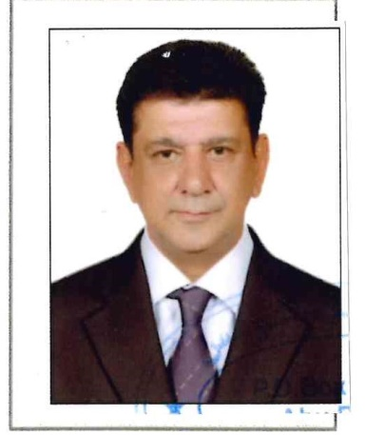

CURRICULUM VITAE
Seeking for a position of store keeper /store keeper assistant with my reputed organization where my education &experience will have valuable application

Objective
To be a part of growing organization which gives a challenging career in items accomplishing the responsibilities, where I can optimize my excellent education and expose and communication skills also to be improves myself by continues learning in and outside the horizon of my responsibilities such as: I can contribute to the progress of the organization.

Personal Identification
Name = Sunil
Sex = Male
Marital Status = Married
Date of Birth = 20 /09 / 1971
Email = sunil.374684@2freemail.com
Nationality =Indian

Educational Status
(1) SSC, Certificate from Mumbai , india

Training Status
(1) I have completed basic training of Food Hygiene, Fire Drill, Frist Aid, Harmful Chemical Handling, and Good Practice of Stores.
(2) Essential food training of Abu Dhabi

Additional Skills and Abilities
(1) I have skilled on accounting software AXAPATA used in stores.
(2) Computer Skills: MS (Word, Power-Point, Excel) Outlook email internet.

Work Experiences
- Currently working at Royal Catering Services L.L.C Mussafah, Abu Dhabi UAE from March 2015 till date, As Store Keeper Assistant
- Receive store and issue all materials in food store and general store
- Issue and enter receipts in the system as and when it takes place
- Take physical stock and monitor the expiry dates of all item to control wastage
- Store all the items as per prescribed standards, to maintain good quality off all materials
- Receive the materials from supplier and check the document as per approved purchase order and invoice for proper materials ,
- Issue materials accurately and follow the FIFO method as per approve requisition
- Update online entries for ordering and stock monitoring
- Store and arrange materials as per standard storage requirement

- Previous Company working at RK pets world , navimumbai (India) from 2009 to 2015.

About Me
I’m friendly, hardworking can work under pressure & having strength to handle overcome obstacles. Looking for a challenging hospitality Job.

Certificates

