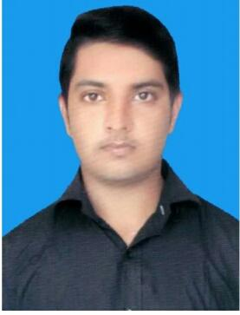
Name: Ali

Position: Civil Supervisor/Foreman

Education: Diploma of associate engineer civil (3 years)

E: ali.374707@2freemail.com

KEY SKILLS

Civil Supervisor/Foreman Layout of Structures

Making Bar banding schedule. Maintain Quality of Material.

Control labour.

- Work according to design/drawings

Experience: 3 years of experience in construction of villas & buildings

EDUCATION

Diploma of associate engineer civil | 2012 – 2015
Government college of technology Rasul Mandi Bahauddin

Distinction average (70%)

High Distinctions: Civil Engineering

Distinctions: Civil Engineering Design

PROFESSIONAL EXPERIENCE

Job Position: Civil Supervisor/Foreman | Mar 2015 - Present

Company Name: Ideal engineering and constructors pvt limited Bhimbar AJK Pakistan

Description

Civil Supervisor at projects.

Completed rotations through Building Services.

Senior Civil Supervisor on a project to determine the ongoing stability of concrete.

Shadowed Associate Engineering Consultants working on an industrial development and gained insight into flood planning, the use of fibre reinforced slabs and gantry cranes.

PROJECTS:

- Government veterinary hospital head jaggu gujrat.

- Government special education center saray alamgir.

- E Library gujrat.

- Government Primary model school Chak No:43

- Government Primary model school Dhok mera

Personal Details

Date of Birth : | : | 25-10-1995
Gender | : | Male
Religion | : | Muslim
Nationality | : | Pakistani
Marital Status: | Single
Language Known. : |  | English, Urdu, Hindi

