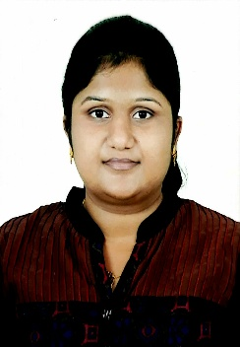
JESSY
Abu Dhabi
E-mail :- jessy.374723@2freemail.com

OBJECTIVE

To obtain any responsible and challenging position that will suit my qualifications. To develop my knowledge and skills that will offer opportunities for personal and professional growth.

Work Experience

Tele Communication and Networking
- Worked for 6 months as CSA in First Source Hubli.
Admin and Counselling

- Front office and Hr. Assist– 2yrs 2 months in Able Design Engineering Services , Hubli.
- PRO (Parents Representative Officer) –15 months in Jain Toddlers Hubli.

Summary of Qualification
- Passed 10th from B.M.E.M School, Hubli
- Completed B.COM in KSOU.
- Completed degree MBA (HR). (3 SEMESTERS)

Skills and Abilities

- Having good Knowledge of English to communicate with customers.
- Capable to create document by using reference which help in future for study purpose.
- Providing customers requirement properly and ensuring the customers.
- Finishing assigned work on time.

Computer Knowledge

- Good knowledge in MS office.
- Good Knowledge in Telecommunications.
- Good Knowledge in Networking.
- Internet and E-mail

Summary of Task Performed

- Giving personalized services to Customers
- Handling Customers complaints.
- Attending Customers Calls.
- Maintaining all the employee personal file.
- Responsible for store pick up and maintaining inventory.
- Responsible for all duties assigning to the juniors.
- Preparing the cheques.
- Maintaining salary statement
- Preparation of salary statement
- Preparations of ESI and PF documents
- Counselling parents do admission.
- Taking care of admission procedures.
- Sending daily report.
- Handling class in absence of teacher.
- And making arrangements for events.

Personal Profile

Name : Jessy
Date of Birth : 21/04/1991
Martial Status : Married
Language : English, Hindi, Malayalam, Tamil, Telegu, and Kannada
Gender : Female
Nationality : Indian
Passport Details

Date of Issue : 21/08/2017
Date of Expiry : 20/08/2027
Place of Birth : Kannur, Kerala India
Declaration

I here by declare that the above information furnished by me is true and correct to the best of my knowledge and belief.
Date:
Place: Abu Dhabi JESSY

