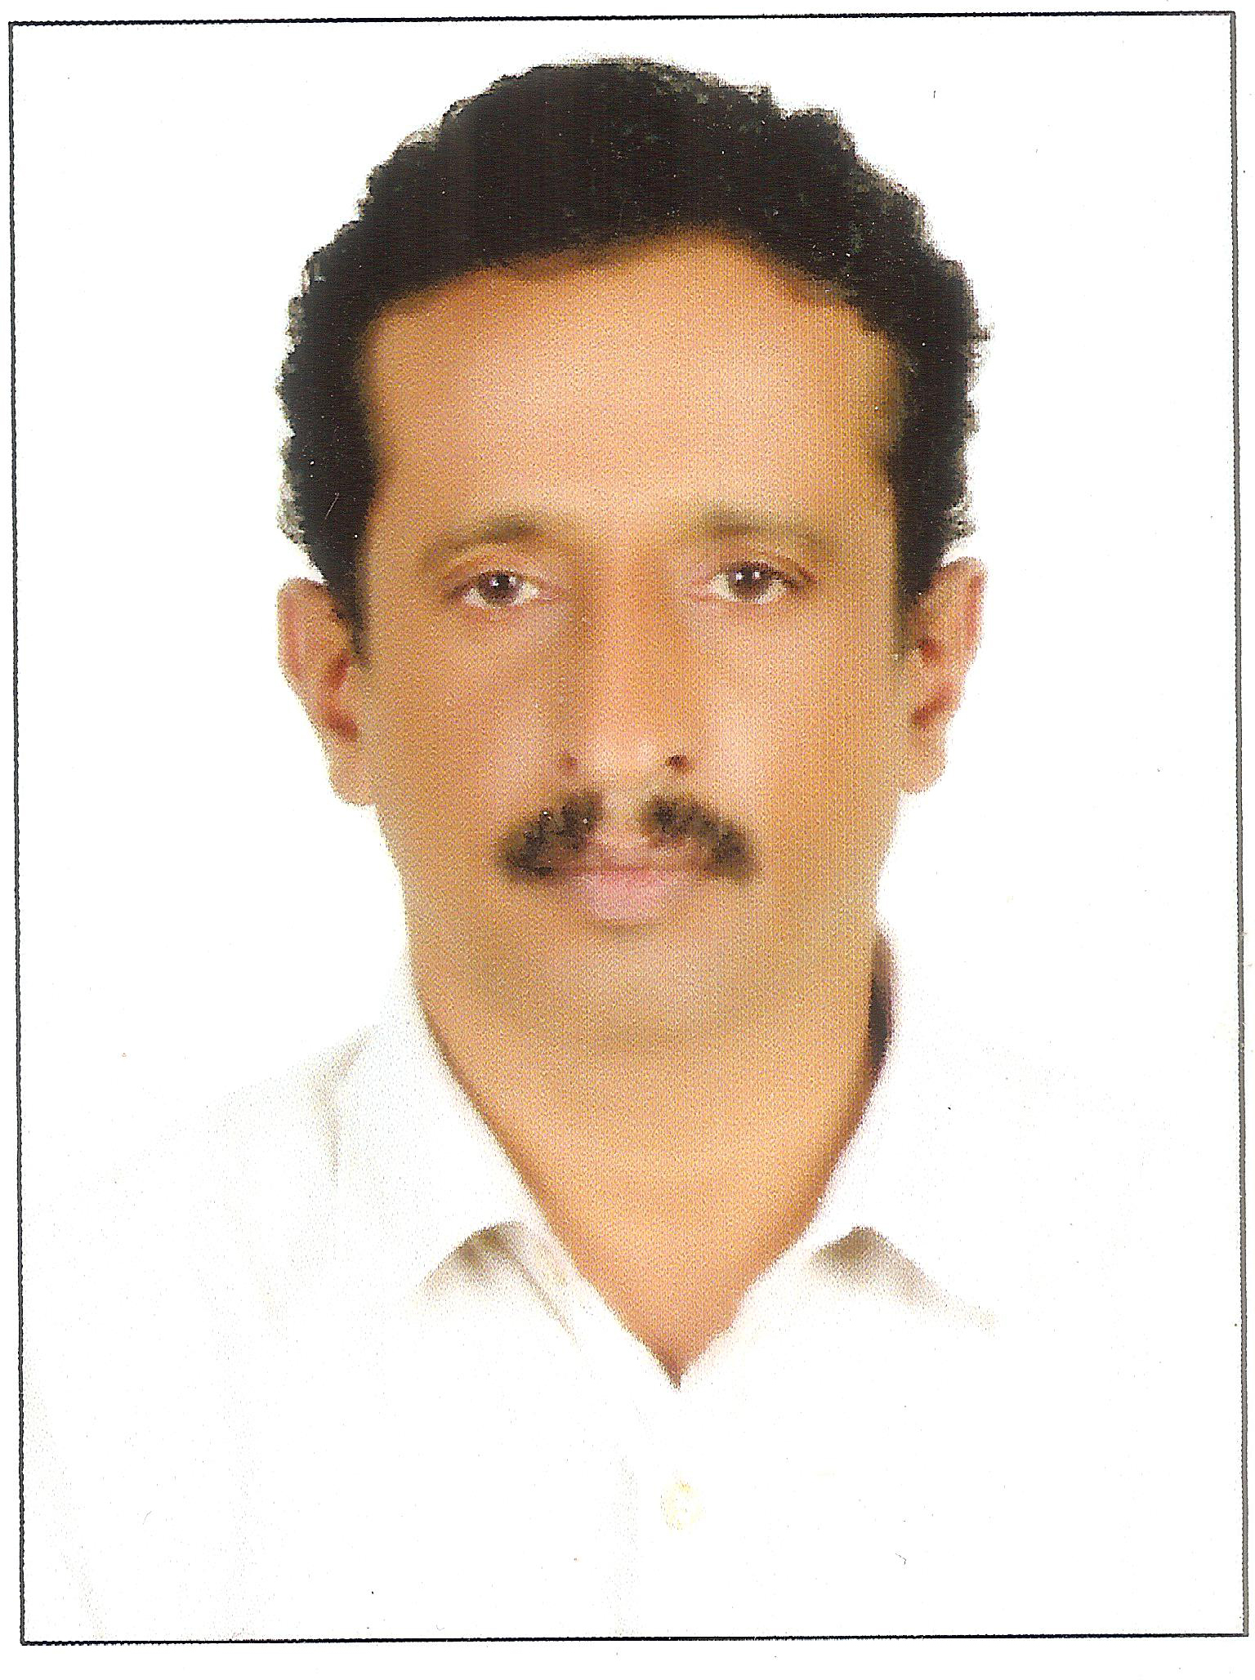
CURRICULAM VITAE

EDISON
Email: Edison.374724@2freemail.com

Post Applied For: H/D Crane Operator-Crawler & RT Mobile

OBJECTIVE:
To develop a professional expertise in the field of Lifting Operations by adopting and implementing latest technologies in the field with a view to minimize incident, accident and property damage of organization. Develop a Safety culture in the organization during my service tenures.

PERSONAL DATA:
Name : EDISON
Profession : Heavy Duty Crane Operator
Nationality : Indian
Expiry : 12th May 2021
Date of Birth : 25.05.1966
Civil Status : Married

PROFESSIONAL EXPERIENCE:

11 Years Experience as Crane Operator in U.A.E, 10 years as Heavy Equipments Operator.

From November 2016 working with Al Shafar Steel Engineering LLC(Accent), Dubai, UAE as RT Mobile Crane operator.

July 2013 to December 2015
Heavy Duty Crane Operator at National petroleum Construction Company, Abu dhabi, U.A.E.
June 2011 to 19th April 2013 as Crane Operator (Crawler Crane & Mobile Crane)

Organisation : Kharafi National, Project: IGD 5-HABSHAN, Abudhabi.
Position : Crane Operator
November 2005 to May 2010(Crane Operator)

Organisation : Punj Lloyd Ltd., Project: ADCO, Gasco & BOROUGE II Project
Position : Crane Operator, Location: Habshan & Ruwaise, Abu Dhabi, U.A.E.

Nov.96 to July 2004 (Heavy Equipment Operator)

Organisation : Al Wadi General Transports & Contracting Company
Position : Heavy Equipment Operator Location : Mussafa, Abu Dhabi.

Dec.93 to March 1996 (Bull-Dozer Operator cum Mechanic)
Organisation : Al-Dhahry International Group
Position : Operator cum Mechanic
Location : Riyadh, KSA
(86 to 93 in India as a Heavy Equipment Operator)

EDUCATIONAL QUALIFICATION:

1 | Bachelor of Arts (economics) Madras University (discontinued)
2 | Office Secretary & PRO Training from Accounts Service Society,kerala
3 | +2 (Higher Secondary Educational Course)
4 | Secondary School Leaving Certificate

TECHNICAL QUALIFICATION:
1 | Offshore Crane Operator Course Certificate from Viswam Institute of Engineering and Technology, Tamil Nadu, India.
2 | Crane Operator Course from Trichy Govt. Polytechnic, Tamil Nadu, India
3 | Back-hoe Loader, Excavator Operator Course from MIHM Technical Institute.

DRIVING SKILLS:
1 | Indian Driving License (Motorcycle, Light Vehicles, Crane Operator)
2 | UAE Light Vehicles & Heavy tractor (Heavy Equipment) Issue date:10/1999, Expiry date:10/2019

LANGUAGE SKILLS: English, Tamil, Malayalam, Hindi & Arabic.

DECLARATION:

I hereby declare that above mentioned details are true to the best of my knowledge and belief.

EDISON

