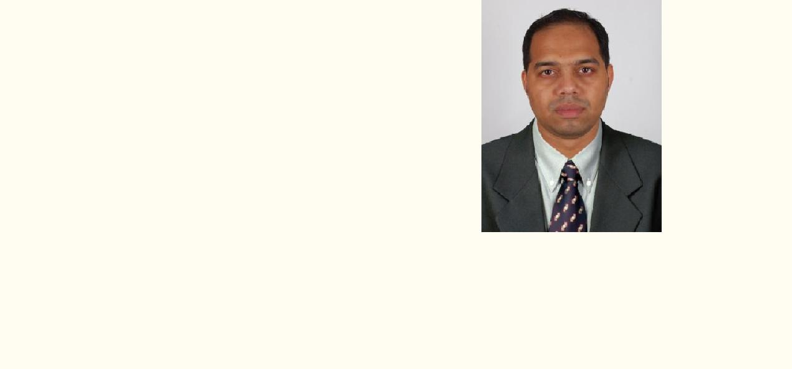

Pragheen
 |  | Email: pragheen.374732@2freemail.com
Personal Details:
Date of birth | : | 2nd December 1983
Marital status | : | Married.
Nationality | : | Indian.
Language Known: |  | English, Hindi, Malayalam & Marathi

ABOUT MY SELF

I would describe myself as a very determined and highly motivated person. I do take my job seriously but I’m able to see things in perspective and believe I’m quite easy-going to work with. I’m an optimist rather than a pessimist – but I’m also a realist and I cope well when the going gets tough; I’m very good at finding solutions to problems. Above all, I would say I’m a positive and enthusiastic person – and I relish a challenge.

EMPLOYMENT OBJECTIVE

Travel Consultant in the air travel sector, with a focus on sales and client relation where my more than 09years of progressive experience in the industry can add value to a customer-centric team.

SKILLS AND ABILITIES

Extensive experience in servicing customers, both in-person and by telephone, in the Air transportation industry. An independent self-starter.

Superior communications skills in dealing with customers, co-workers, and employees. Both verbal and written skills are strong.

Well-organized and highly efficient working in a multi-tasking dynamic environment. Ability to plan, organizes, and supervises the work of others.

Knowledgeable and experienced in travel agency operations. Possess a strong combination of training and experience in the industry.

Skilled in cultivating excellent relationships with both clients and colleagues

WORK EXPERIENCE:

1. Sr.Travel Consultant: Krisbi Travel Inc. 15Dec 2014 till now. (Working on AMADEUS SYSTEM)

Handling retail & co-operate clients

2. Branch In charge: Alhashar tourism and travels LLC [MUSCAT- SULTANATE OF OMAN]

(Worked on SABRE SYSTEM) From 04 Sep 2013 to 06 Nov.2014

Handle walk in cleints& co-operate clients

3.Sr.Travel Consultant: Flight searches Pvt ltd. 25feb.13to 31 Aug 13. (Worked on world span System)

Name of Process: Omega Flight Store (London, U.K) Retail clients.

4. Travel Consultant: Infoscape, Inc. 04 Feb 08to 15 Feb 13 (Worked on AMADEUS SYSTEM)

Name of Process: Krisbi Travel Inc. (Detroit, U.S.A)

Handle retail & co-operate clients

Prepare cost effective travel plans

Ensure reservations are on the correct date

Processed client profiles and organized office systems to ensure smooth workflow

Developed strong relationships with managers and staff, creating a cohesive and productive team within a deadline-driven environment

Training new departmental members on sales techniques, training on Amadeus & Sabre reservation system

Supervise

Attending phone calls, handling travel enquiries, doing reservation and issuing tickets

Handling corporate clients, group bookings & subagents

Answer phones professionally, courteously and promptly.

Make professional, accurate, cost effective travel arrangements for clients while providing excellent customer service.

Prepared detailed itineraries upon bookings to ensure accuracy of reservations and provided confirmation to clients.

EDUCATION:

Diploma in International Airlines & Travel management, IITC MUMBAI (2008-2009)

Diploma in Computer Programming & Application,Global computer Institute, Mumbai, (2004)

Higher Secondary Graduate –Commerce, Mumbai, 2003

Bachelor of Commerce TYB.com-2012-13

Key Competencies:

Attention to detail and quality Customer service orientation

Communication and interpersonal skills&Team Work DATE:-

SIGNATURE:-

