E-mail: haider.374733@2freemail.com  CNIC 34101-0936921-5  Date of Birth 4 Jan 1994  Languages English, Urdu  Nationality Pakistani  Lives In Gujranwala  Gender Male  Age 23  acadimic profile  BISE : F.A  2013 – 2015  BISE : Matriculation Com-Science  2009 – 2011  Certification  Ms Windows  MS Excle  Ms Word  Ms Power Point  Professional Experience  Global technologies  CCTV Technician  2013-2016  Installation of System on Particular Sites.  Projects  Hospitals  Super Markets  Flats , Building  Shops  Factories  Furnases |  | Haider  Low Voltage Technician  CCTV Executive  Imtiaz super market (Punjab, Pakistan) 2016 – 2017  I have completed the Branches, Flats and warehouse projects. Including but not limited to CCTV and Access control.  - Supervised the Team.  - CCTV Commissioning & Diagram Reading.  - Installation Cable Tray, wiring, Patch Panel & communication Racks.  - Fire Alarm System Installation , Smoke-Detectors , Multi-Detectors , Sounders , Control Panel , Manual call Point  - Public Address System , Voice Alarm Controller , Mixer-Amplifiers , Cabinet Speaker , Box Speakers Installation  - Monitoring more than 100 IP Camera’s Nodes & Wiring Loop Comparatives.  Archivements  To Utilize My Professional Skills in a Demanding Working Environment that Requires Continues Excellent Performance and provides Self-Development Opportunity.  SKILLS  SOFTWARE  - CCTV Analog & IP Camera.  - NVR & DVR  - Access Control  - Fire Alarm System , Manual Call Point  - Public Address System  - PoE Switches, SD & MD, Intercom  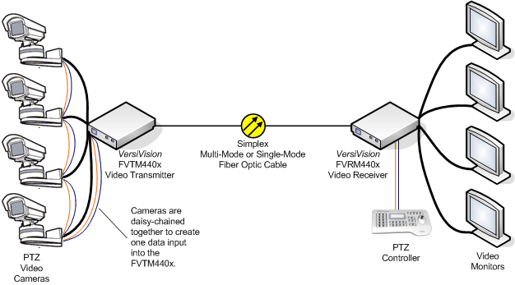  - Installation, Configuration and Maintenance  - Troubleshooting Skills  Worked on Brands:

