 |  | RESUME
Name: | MERLY
 | DHA LICENCE |  |  |  | HOLDER
Email Id:
 | Merly.374739@2freemail.com
Date of birth: | 23-DEC-1991
Nationality | : Indian
Languages | : English, Hindi, Malayalam
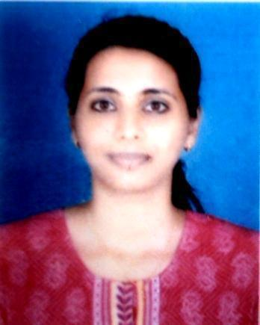

OBJECTIVE

Great career and growth opportunities along with learning environment, where my performance will meet organization’s goal.

PRESENT STATUS

Working with Al Jaber Opticals (Dubai) as Optometrist since July 2016 till date.

(16 Months)

MEMBERSHIP
Indian Optometry Association LM number 02082/014

1

EDUCATIONAL PROFILE

 |  |  |  |  |  |  |  |  |  |  |  |  | YEAR |  |  |  | MARKS
 |  |  |  |  |  |  |  | BOARD/ |  |  |  |  | OF
COURSE |  |  |  | INSTITUTION |  |  |  |  |  |  |  |  |  |  |  | %
 |  |  |  |  |  |  | UNIVERSITY |  |  |  |  | COMPLETION
B. Optometry |  |  |  | BVP Pune |  | Bharathi Vidyapeeth |  |  |  |  | 2009-2013 |  |  |  |  | 64%
 |  |  |  |  |  |  | University
 | H.S.C |  | St. Xavier School, |  |  |  |  | C.B.S.E
 |  |  |  |  |  |  |  |  |  |  | 2009 |  |  |  |  | 72%
 |  |  |  | Jaipur
 | S.S.C |  | St. Xavier School, |  |  |  |  | C.B.S.E |  |  | 2007 |  |  |  |  | 81%
 |  |  |  | Jaipur

CLINICAL WORK EXPERIENCE

- Worked in Centre For Sight Hospital from November 2013 to May 2016. (31 Months)

WORK PROFILE DURING INTERNSHIP

- 12 months of internship as a fulfillment of Bachelor program, at LV Prasad Eye Institute, Vishakhapatnam

All out patient department includes case history, objective and subjective refraction, slit lamp evaluation, applanation tonometry

JOB ROLE

- Taking case history and in assessing various refractive errors like myopia, hyperopia, astigmatism

- Efficient in doing subjective and objective refraction in all types of refractive errors

- Efficient in doing contact lens which includes Soft contact lens, Rigid Gas Permeable, Piggy Bag Lens, Rose K Lenses, Prosthetic lenses and Prosthetic eye.

2

- Familiar with all types of frames and lenses single vision, bifocals, progressive addition lenses with all types of lens coatings.

RESEARCH EXPERIENCE

“Ocular manifestation in HIV patients in the post-highly active anti-retroviral Therapy era presenting at a tertiary care ophthalmic centre in coastal Andhra”

DECLARATION

I hereby declare that all the above furnished information is true to best of my knowledge and belief. The originals will be produced as required.

Merly
Place: Dubai, UAE

3

