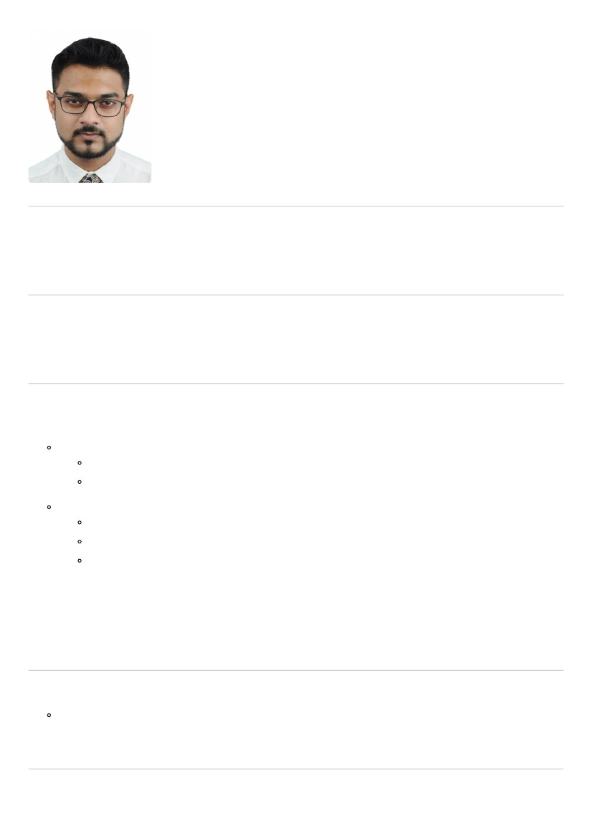
RAJIT
§ rajit.374745@2freemail.com
E-ma
Address
Dubai
SUMMARY
A Graduate in Computer Applications with an experience of more than 2 years looking for a suitable opportunity
in various sectors in the U.A.E.
OBJECTIVE
My goal is to become associated with a company where I can utilize my skills and gain further experience while
enhancing the company’s productivity and reputation.
WORK EXPERIENCE
Tech Mahindra-India
Assosiate Software Engineer
Worked as a Software & License Procurement Analyst under Synchrony Financial Project.
Procurement of Licenses and software globally
Domain - Banking
Worked as a Load monitoring & Report Analyst under MTN-BI Project.
Monitoring of daily data load
Handling of issues and creation of reports
Domain - Telecom
August 2015 — November 2017
Software Skills - Unix, SQL & Ab Initio (Basic)
QUALIFICATIONS
Graduate Degree
Bachelors in Computer Applications (BCA) [2012-2015]
EDUCATION
Secondary
The Modern Academy, India
RAJIT
1
— March 2010

Higher Secondary
The Modern Academy, India
— March 2012
Bachelors in Computer Applications
The Heritage Academy, India
August 2012 — May 2015
INTERESTS
Music, Numismatics, Playing Synthesizer
SKILLS
Team Player
Interpersonal Skills
Ability to build relationships
OTHER INFORMATION
Date of Birth - 09/11/1993
Nationality - Indian
REFERENCES
References available upon request.
RAJIT
2

