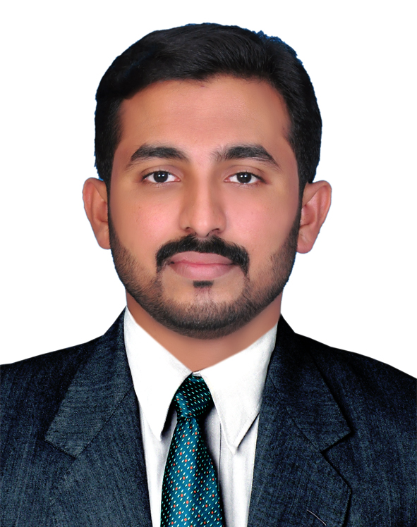  E-mail:  Shafeeque.374747@2freemail.com  Date of Birth:  09-03-1988  Nationality:  Indian  Marital Status:  Married  LanguagesKnown :  English, Hindi & Malayalam, Arabic  Hobbies :  Playing cricket, surfing internet, reading magazines and journals, reading newspaper.  Visa status :  Employment Visa. | SHAFEEQUE  Career Objective  A Graduate in B.Com (finance and Co-Operation) with 7 years of experience in Accounting, Administration, Financial analyzing, convincing the customers and generating leads. Seeking a challenging job to deliver best of my skills and make best use of my efforts in gaining experience and in making a positive difference to the organization.  Professional Summary / Areas of Expertise  - Excellent interpersonal skills quickly developing report.  - Participated in various cultural activities and in management fests.  - Member of Event organizing committee in the College.  Academic Qualifications  - Bachelor of Commerce  Kannur University, Kerala, India -2009  Higher Secondary (Science) - (KERALA) – 2006 From B.A.R.H.S.S Bovikanam  S.S.L.C (KERALA) – 2004 From B.A.R.H.S.S Bovikanam  Professional Experience  Employer : Master Automotive Service  Center  Designation : Accountant.  Duration : From 01-05-2016 onwards.  Responsibilities  - Apply Basic accounting knowledge & techniques to all areas of work, including the production of journals, routine costing & variance analysis  - Dealing with finance transactions of company, credits & collection management on Out-standings.  - Preparation of year ending schedules & accounts for Audit.  - Maintaining Purchase & sales including stock register.  - Coordinating with sales & purchase for effectiveness of business.  - Preparing Salary, Finalizing of financial account like, Balance Sheet, P&L, MPR, MCR  - Submission Of Insurance Invoices to Insurance Company Like, Adnic, Aldhafra, Adamjee, Methacq , Orient …  - Bank Reconciliation
Employer : Maruti Suzuki Popular Vehicles And Services Pvt.Ltd
Designation : Accounts In-charge
Duration : From 1st September 2012 to 20th Februalry2016

Responsibilities

- Apply Basic accounting knowledge & techniques to all areas of work, including the production of journals, routine costing & variance analysis
- Dealing with finance transactions of company, credits & collection management on Out-standings.
- Specialized in Submitting Sales Tax & Returns, Service Tax, TDS, ESI
- Preparation of year ending schedules & accounts for Audit.
- Maintaining Purchase & sales including stock register.
- Coordinating with sales & purchase for effectiveness of business.
- Preparing Salary, Finalizing of financial account like, Balance Sheet, P&L, MPR, MCR
- Bank (daily) and Inter branch reconciliation on Monthly basis.
- Send collection report to HO weekly basis
- Preparation of AOP

Employer : Lanmark Shops India Pvt Ltd. Kasaragod Branch
Designation : Accountant
Duration : From18TH April 2011 to 31ST AUG 2012

Responsibilities

- Apply Basic accounting knowledge & techniques to all areas of work, including the production of journals, routine costing & variance analysis
- Dealing with finance transactions of company, credits & collection management on Out-standings.
- Specialized in Submitting Sales Tax & Returns, TDS
- Preparation of year ending schedules & accounts for Audit.
- Maintaining Purchase & sales including stock register.
- Coordinating with sales & purchase for effectiveness of business.
- Preparing Salary, Finalizing of financial account like, Balance Sheet, P&L

Responsibilities

Employer : Viswas Consultancy( Chartered Accountant Firm)
Designation : Accountant/ Audit Assistant
Duration : From 1ST September 2009 to 14TH April 2011

- Apply Basic accounting knowledge & techniques to all areas of work, including the production of journals, routine costing & variance analysis of various companies
- Specialized in Submitting Sales Tax & Returns, Service Tax, TDS, ESI various companies
- Preparation of year ending schedules & accounts for Audit
- Preparing Salary
- Finalizing of financial account like, Balance Sheet, P&L
- Auditing of Bank like SBT, KARNATAKA BANK, CANARA BANK, FEDERAL BANK, SYNDICATE BANK…
Technical Proficiency
- Financial Accounting & Tax, Business Management (Accounting Software’s: TallyERP 9, Tradeasy, DMS, WINGS).
- Microsoft Office: MS Excel, MS Word, MS Power point,
- Operating Systems: XP, Windows 7

Training and Certification
- Financial Accounting with Tally from Edit Computer Center (C-DAC GIST PACE programme (Date of issue of certificate 09-10-2009 Awarded grade A)
- Office Secretary /PRO training from Accountant Service Society (6 Month course (Date of issue of certificate 21-06-2010. Awarded grade A)
- Certifcate Examination in Life Insurance from Insurance Institute of India (Date of issue of certificate 12-06-2010. License No:7586004185)(Two year work experience as Financial Advisor (Part time) from ICICI Prudential Life Insurance and six month Experience as Financial Executive from HDFC BANK (Part time)

Award and Recognition
- Most Dedicated Employee Award (2016-2017)From MASTER AUTOMOTIVE SERVICE CENTER

Skills
- Innovative with Positive Attitude.
- Effective Inter-personal skills and Good in building & maintaining relationships.
- Problem solving ability.
- Strong counseling & convincing techniques.
- Leadership Quality & team work.
- Adaptable to new environment and people.
- Flexibility to work on shifts/overtime/stand-by/on-call/holidays when required.
- Self motivated, hard working and smart working.
- Excellent oral and written communication skill.

Declaration:

I hereby declare that the information furnished above is true and correct to the best of my knowledge and will furnish other details on request.

Date :
Place :Abu Dhabi (sHAFEEQUE)

