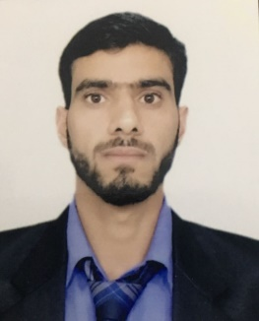
CAREER OBJECTIVE:

Mr. ASHRAF
E-mail Id: ashraf.374753@2freemail.com
Visit VISA Valid Upto: 18/01/2018

To Associate myself with an organization having global presence and tremendous growth opportunities and to enhance my knowledge and skill, thereby proving myself an asset for the organization.
CAREER PROFILE/ SKILLS

- A product of University of Kashmir (Top ranked university of Asia).
- Good communicator- Mature, Patient, Responsible and positive.
- Passionate and Energetic.
- Master of the skills.
PROFESSIONAL WORK EXPERIENCE

Certified English Teacher with 5⁺ Years of Teaching Experience in Best Schools of Srinagar Jammu and Kashmir, India.

- ORGANISATION:
- Hyderia Model High School (Top ranked institute in Srinagar).
- Tenure: 05-04-2010 / 07-04-2011.
- Designation: Teacher.
- Responsibilities: To Master 4 skills of Language learning to students. Classroom management.
- Achievements: IPA Introduction in school a great achievement.
- Evaluated the student classwork and Assignments.

- ORGANISATION:
- New Dream Land Educational Institute Ganderbal (Leading higher secondary in Kashmir valley).
- Tenure: April 2011 – October 2013.
- Designation: Teacher.
- Reasonability: Over all Development of Students.
- Achievements: IPA Introduction in school a great achievement.

- ORGANISATION :
- Waheed Memorial Model School (The Grand School in Srinagar).
- Tenure: May 02/2014 To Nov 25/2016
- Designation: Teacher/ Principal.
- Responsibilities: Analyzing School curriculum.
- Communication with parents, students and public for betterment of student.
- Maintained overall management of school.
- Achievements: Introduction of Arabic as language and introduction of
Academic Education

Degree/Certification | Examining Body | Year
Masters in English | University of Kashmir | 2010
B.ED | University of Kashmir | 2011
Certification/Additional Skills:

- One year Diploma in Computer Application.
Training and Workshops:

- Teacher training course through university of Kashmir 2011.
PERSONAL INFORMATION:

- Date of Birth: 08/Nov/1986
- Marital Status: Unmarried.
- Driving License: NA

