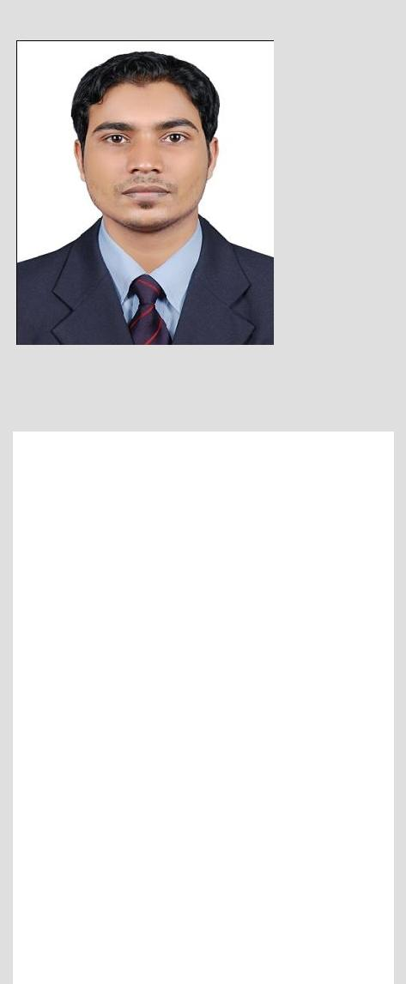

BADARUDHEEN
ASSISTANT PHARMACIST

Email: badarudheen.374769@2freemail.com
Dubai
Personal Data
Date of birth : 29/04/1989 Nationality : Indian. Marital Status : Single.
Languages Known
English, Malayalam, Hindi,
Tamil, Arabic.
CAREER OBJECTIVE & INNOVATIVE

Seeking a challenging career in the field of PHARMACY, in a professionally with learning and growth opportunities. To develop my career by working in a dynamic institution/organization that offers challenging position and duties that will both effectively challenge and enable me to utilize and incorporate my technical experience and professional skills. This will enable me to contribute positively towards the achievements of the organizational and institutional goals and advancement of my career.

EDUCATIONAL QUALIFICATION

Master of Pharmacy (2014-2017), JKKMMRF College of Pharmacy, Erode, Tamilnadu,

India.

Bachelor of Pharmacy (2008-2013), JKKMMRF College of Pharmacy, Erode, Tamilnadu,

India.

HigherSecondary Education (2005-2008), GHSS Kumaranellur, Palakkad. Kerala, India.

SSLC (2005), Darul hidaya higher secondary school, Edappal, Malappuram, Kerala, India.

PROFESSIONAL EXPERIENCE

Organization: Shanthi Medical Centre Edappal Pvt. Ltd

Designation: Pharmacy (Pharmacist) Sep 2013 to Jan 2014.

KEY DELIVERABLES

- Manage all aspects of the pharmacy operations

- Reviews prescriptions issued by the Physician, or other authorized prescriber to assure accuracy,

- Appropriateness of medication, and determine formulas and ingredients needed; check for expired

medications.
- Take in and handle out prescriptions, Dispense prescriptions.

- Use store’s computer systems to generate label and stock lists. Help in maintaining reasonable dispensary stock levels.

- Order items for use within and outside department.

- Receive, load and unload incoming goods from manufacturers, wholesalers and elsewhere.

- Deliver pharmaceuticals goods to sites within a pharmacy department and clinical areas/wards/departments.

- Sell over the counter medicines also.

- Answer queries on the availability and supply of medicines.

- Manage the cash register.

COMPUTER SKILLS

Well versed in Microsoft Office 2010: Excel, Word, PowerPoint and Internet.

PERSONAL ATTRIBUTE
- Ability to negotiate and influence.

- Confident communicator in a variety of presentation situations..

- Trustworthy, friendly and approachable.

- Good Analytical and problem solving abilities.

- Recognized for sincere, responsible, hard working and positive attitude

- Quick learner, team worker and innovative thinker

DECLARATION

I, sincerely hope that my application will receive your kind attention and if I am given an opportunity to prove myself I will surely try to give maximum level of satisfaction.

BADARUDHEEN

