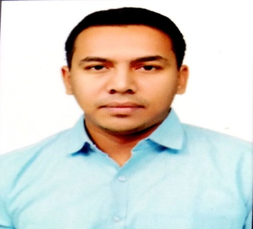
CURRICULUM VITAE
MOHD
Email-: mohd.374772@2freemail.com

CAREER OBJECTIVE
To apply the acquired skills and knowledge to create a benchmark for the organization I work for and be recognized as a trendsetting professional.

CAREER HIGHLIGHTS
- Started career by leading a team of 4 members, responsible for marketing and operations of the Educational organization.
- Successfully launched Test series and implemented new marketing plans for increasing revenue for the organization.
- Successful Team leadership of a team of 30 members twice during tenure with a national print media company.
- Planning and leading a team for big projects of the head unit of the national media company.
- Awarded several times during tenure with the national media company.

CAREER ACHIEVEMENTS
- Awarded 3 times as superstar performer at state level by Dainik Bhaskar.
- Awarded 4 times as achiever for the concerned headquarters by Dainik Bhaskar.
- Successfully leading and executing big projects of the headquarters.

PROFESSIONAL SKILLS
- Excellent communications skills.
- Experience of Team leadership.
- Decision making and problem solving abilities.
- Experience of handling big projects.

PROFESSIONAL EXPERIENCE
1) Management associate at Dainik Bhaskar for 23 months.
- Promoted with responsibility of Team leadership of 4 bureau offices for big projects along with response category for the headquarter Dhanbad.
- Promoted to headquarter Dhanbad from Giridih with responsibility of Real estate category.
- Responsibility of leading the bureau team of Giridih along with govt. and commercial category.
2) Marketing Head of an Education Catalyst for 23 months.
- Responsible for leadership of 4 team members for marketing and operational activities.
- Planning and execution for revenue generation and branding for the organization.
- Allocating responsibilities and following up with marketing and operational staffs.

EDUCATIONAL QUALIFICATION
- Passed B.COM Graduation in the year 2012 with 1st division.
- Passed intermediate from CBSE with 1st division.
- Passed matriculation from ICSE with 1st division.

PERSONAL DETAILS
Date of birth -: 22nd march, 1990.
Languages known -: English, Hindi and Arabic (Reading).
Hobbies -: Travelling to new places, visiting historical monuments, outdoor sports.
Visa status -: Visit visa for 1 month.
Passport number -: P7764866

