CURRICULUM VITAE
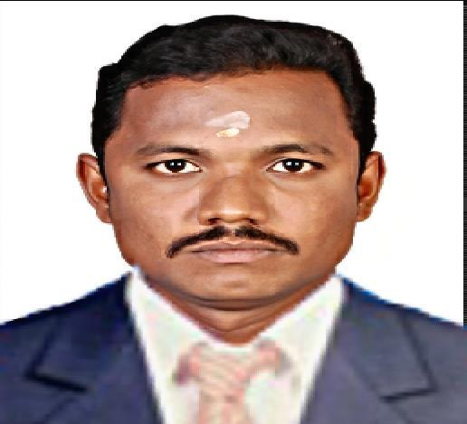

SUDHAKAR

Email: sudhakar.374773@2freemail.com

Visa Status: Visit Visa (Exp Date: 24/01/2018)

OBJECTIVE

An Energetic, Well Organized, Self-Motivated, Versatile, Self-starter, Reliable engineering professional with more than 2 Years of Experience in Mechanical Engineering with good analytical skills in Production and Electromechanical Industry.

EDUCATIONAL QUALIFICATION

- Pursued B.E., Mechanical Engineering in Surya Group of Institutions-ANNA UNIVERSITY-Chennai, India with CGPA of 7.2 in 2013.

EXPERIENCE SUMMARY

- Worked as a PRODUCTION SUPERVISOR – SAFETY Mechanical Engineer in PRIDE MACHINE TOOLS, Bangalore, India From JUNE2013 TO JANUARY 2015.

- Worked as a PROJECT SITE ENGINEER – MEP Mechanical Engineering in ADITYA BUILDERS AND PROMOTORS, Bangalore, India From APRIL 2015 TO SEPTEMBER 2017.

SKILL SUMMARY

- Significant production management experience

- Exceptional expertise in commissioning and installing HVAC equipment like AHU, CSU & FCU’s

- Sound knowledge of sizing, layout and MEP projects

- Profound knowledge in production to increase the rate of production.

- Profound skill in construction and investigation services

- Outstanding budget and project management skills

- Superior organizational and communication skills

- Remarkable ability to understand design codes and its specifications

- Immense ability to manage budget and meet all deadlines

- Proficient in providing investigation and construction services

SOFTWARE PROFIENCY

- AUTO CADD

- BASIC ANSYS

- CATIA

- SOLID WORKS

PROFESSIONAL EXPERIENCE

- ORGANISATION: PRIDE MACHINE TOOLS LTD, BANGLORE, INDIA.

POSITION: PROJECT SUPERVISOR – MECHANICAL ENGINEERING

DURATION: FROM JUNE 2013 TO JANUARY 2016.

PROJECT: CNC LATHE MACHINES (PROTURN,ULTRA LYNX, PARAM350)

- ORGANISATION: ADITYA BUILDERS&PROMOTORS,BANGALORE,INDIA

POSITION: PROJECT SITE ENGINEER – MEP/SAFETY MECHANICAL ENGG.

DURATION: FROM APRIL 2013 TO SEPTEMBER 2017.

PROJECT: ADITYA VILLAS, ADITYA COMPLEX, APARTMENTS

DUTIES AND RESPOSIBILITES

- Working as Site Engineer. Co-ordination, work allocation and inspecting all MEP works.

- Responsible for handling the entire process of project turnover starting from project initiation to the delivery stage

- Designing complete ventilating and air-conditioning systems for a variety of buildings as well as preparing complete design documentation.

- Prepare/Review the daily production sheet.

- Scheduling all manpower requirement of production.

- Representing project progress & co-ordination meeting with Consultant/Main contractor/Sub contractors

- Performed responsibilities of providing support to the senior engineer in planning the design phase of the project

- Perform the tasks of evaluating the scope of supply and commercial bid of the project

- Assigned the tasks of generating I/O summary as well as perform product development

- Responsible for ensuring that the technical parameters and compliance process are supplied as outlined in the contract documents
- Handled the tasks of assisting senior engineers in planning and installing materials.

PERSONAL PROFILE
➢ Date of Birth |  | : | 18 Oct 1991
➢ Nationality |  | : | Indian
➢ Married Status |  | : | Single
- Linguistic proficiency : Tamil(R/W/S), English(R/W/S)
DECLARATION

I hereby declare that the information stated above is true to my knowledge.

Place :

Date : (SUDHAKAR)

