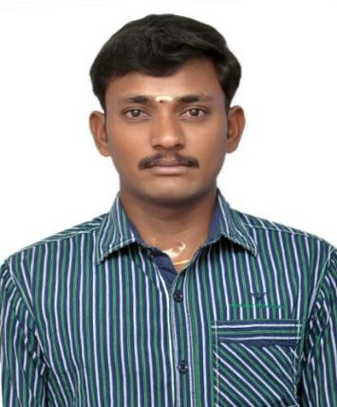

CURRICULAM VITAE
POSTING: SAFETY OFFICER

VIJAYA

Address: ABU DHABI
E-Mail: vijaya.374793@2freemail.com
OBJECTIVE:

To build a challenging carrier in Safety Field with a reputed company and to serve the company with extreme dedication, put forth my knowledge for the benefit of the organization and be a dominant part of the
Company.

EDUCATIONAL QUALIFICATION:

- SSLC
Tagore Matriculation Higher Secondary School
Deviyakuruchi ,Thalaivasal.

TECHNICALQUALIFICATION:

- Post Graduate Diploma in Fire & Safety Engineering
International Institute of Engineering & Technology
Cuddalore.

- First Aid (Senior Professional)
St. John Ambulance
Chennai .

COMPUTER QUALIFICATION:

- Diploma in Computer Application
International Institute of Engineering & Technology
Cuddalore .

EMPLOYMENT EXPERIENCE:

- I am 2 years experience in
Jharsuguda thermal plant (CREW (P) Ltd)
(Only Operation & Maintenance of coal Handling Process)

ROLE & RESPONSIBILITIES:

- Developing and implementing the COMPANY SAFETY PLAN.

- Inspection to locate UNSAFE CONDITIONS or UNSAFE ACTS.

- Organizing FIRST AID Facilities.

- Organizing WORKER’S INSURANCE.

- Organizing SAFETY AUDIT (WALK THROUGH, INTERMEDIATE & COMPREHENSIVE) and Implementing Recommendations of Audit Reports.

- Formulating SAFETY PROCEDURE and SAFETY DOCUMENTATION.

- Formulating Procedures of ACCIDENT INVESTIGATION.

- Maintaining WORK INJURY and ILLNESS RECORD.

- Initiate revision of existing FORMS/CHECKLIST for inspection of equipment and make necessary forms for monitoring of safety at site.

- Implementing the EMERGENCY EVACUATION PLAN and procedures with proper coordination to the nearest hospital.

- Conduct SAFETY INDUCTION CLASS and SAFETY TOOLBOX MEETINGS to all Employees.

- Issue WARNING CITATIONS to those not complying with safety policies and regulations and impose penalty/fines to those doing UNNECESSARY/UNSAFE ACT redundantly which creates to near miss conditions.

- Establish the HSE POSITIVE CULTURE with the project team by making and ensuring effective communication with all levels of employees.

- Investigate and Review all INCIDENT/ACCIDENT DATA for trend and areas of systematic weakness within the department.

- Create METHOD STATEMENT & RISK ASSESMENT for all jobs.

- Maintain all FIRE FIGHTING EQUIPMENTS.

- Save our ENVIRONMENT by applying WASTE SEGREGATION Method.

- Given SPECIAL TRAINING (HOT WORK, HEIGHT WORK & ENVIRONMENTAL SAFETY) to employees for minimize the Accident.

- SELECTION OF PPEs for Specific Work and ISSUE OF PPEs to Employees.

COMPUTER PROFICIENCY:

- Operating Sys : MS-Dos, MS-Windows 98, 2000, XP, Vista & Windows 7,10
- Other Packages : MS-Office, Visual Basic, Photo shop, Page Maker& Coral Draw.
- Hardware : Software and OS Installation, Computer Assembly.

PERSONAL DETAILS:

Name : VIJAYA

Date of Birth : 13.06.1990

Sex : Male

Nationality : Indian

Religion : Hindu

Marital Status : Married

Languages Known : Tamil, English& Malayalam

Passport : Valid up to 23/03/2026

Visa Status : Tourist Visa up to January 20 /2018

DECLARATION

I hereby declare that the particulars furnished above are true to the best of my knowledge.

Place : ABUDHABI
(VIJAYA)

