ABU

E-MAIL: abu.374796@2freemail.com
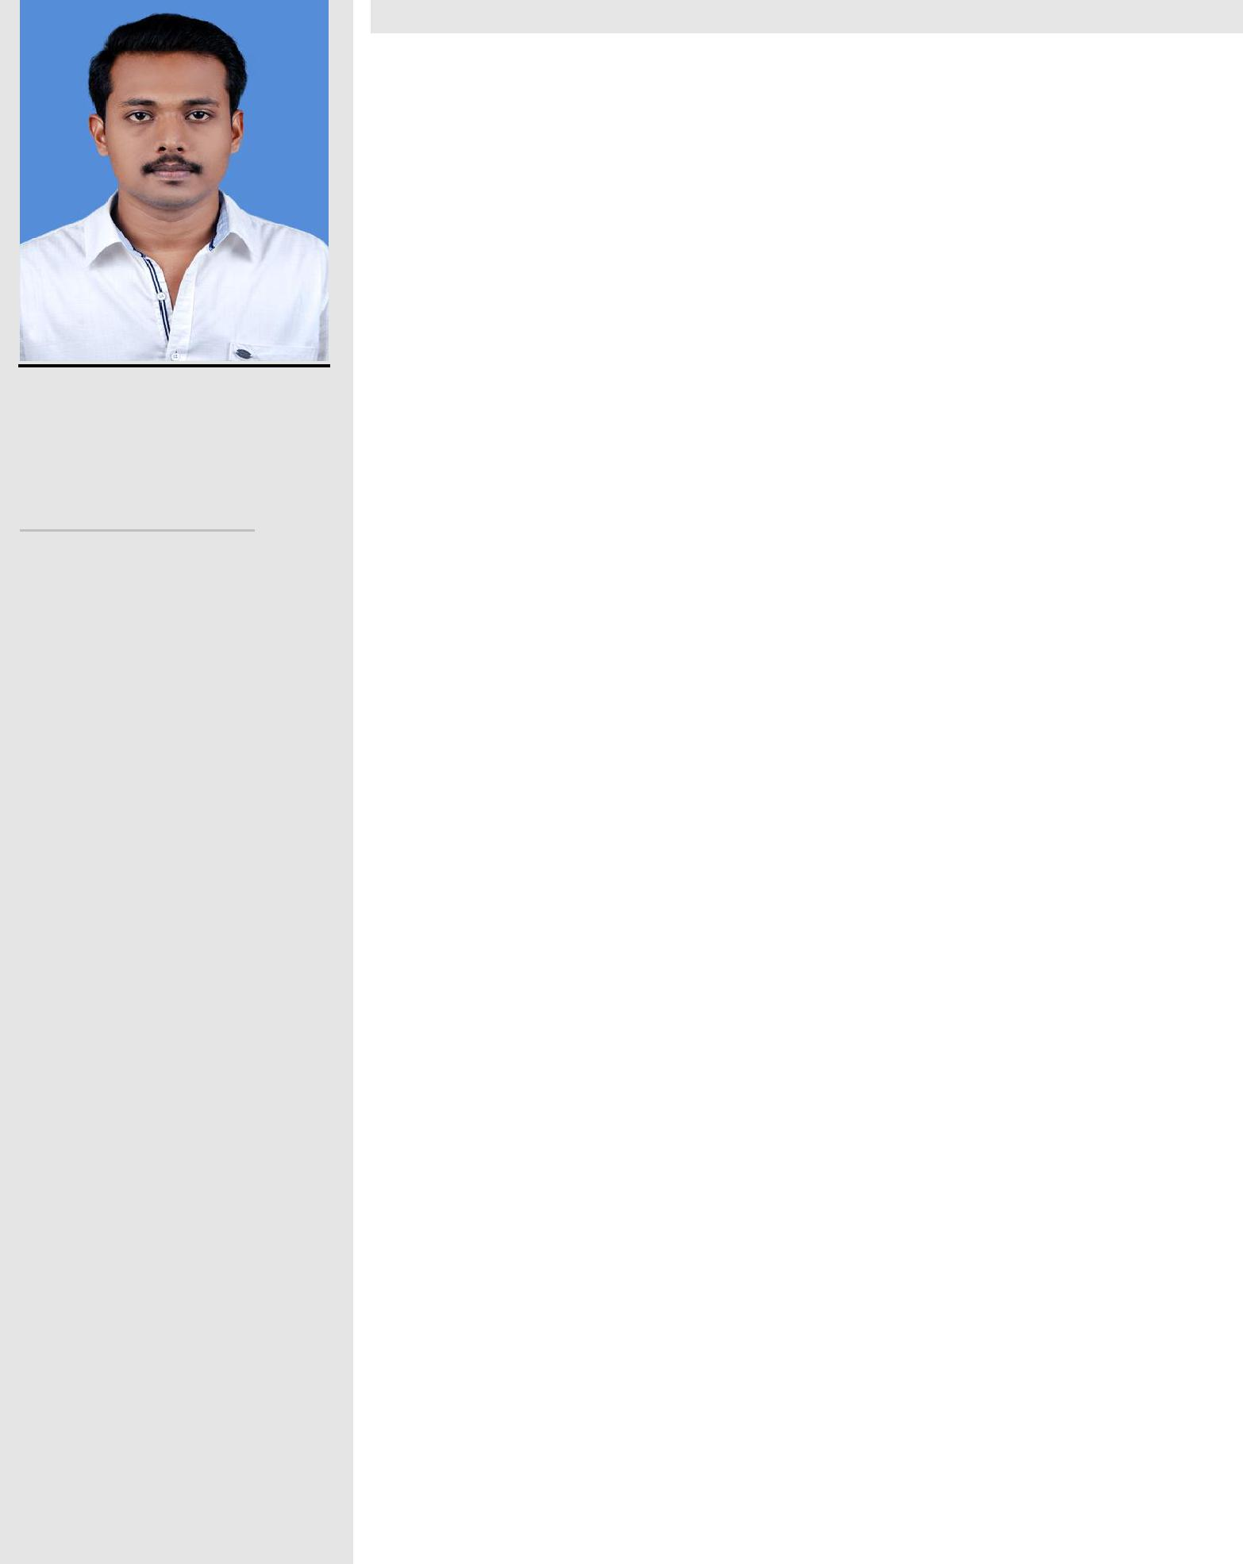

PERSONAL DETAILS

Nationality :Indian

Date of Birth :30.08.1991

Age | : 26
Marital Status :Single

Religion :Christian

Visa Status : Tourist

CAREER OBJECTIVE

To have a growth oriented and challenging career, where I can contribute my knowledge and skills to the organization and enhance my experience through continuous learning and teamwork.

PROFILE: Taking up challenging tasks and projects.

PROFFESINAL OVERVIEW

- Professionally one year experienced as a role of mechanical design engineer trainee in HVAC & Fire fighting.

- Professionally two year experienced as a role of Mechanical Coordinator.

CAREER SNAPSHOT:

1.“ MECHANICAL COORDINATOR” (Nov2014 - Dec2016)

NEW TECH ENGINEERS.

Office: Survey No. 11/3, Shanti Nagar,

Landewadi, Bhosari, Pune – 411039

Phone: (O) 27129022, Cell: 9011452413

Key Responsibilities:

    - Organize workflow and ensure that employees understand their duties or delegated tasks

  - Monitor employee productivity and provide constructive feedback and coaching

- Receive complaints and resolve problems

- Maintain timekeeping and personnel records

- Pass on information from upper management to employees and vice versa

- Prepare and submit performance reports, Hire and train new employees.

 |  |  |  | 2. MECHANICAL DESIGN ENGINEER TRAINEE- in
LANGUAGES KNOWN |  |  |  | HVAC and FIREFITING (Jul2016 - Aug2017)
 |  |  |  |  | AGHORA DEVELOPERS
 | English
▪ |  |  |  |  | 2nd Floor, Salihas complex,
▪ | Hindi |  |  |  | Beach road, kolam
▪ | Malayalam
 |  |  |  |  | home@aghoragroup.com
▪ | Tamil

HOBBIES

- Review of current market scenario

- Reading Newspapers

- Listening Music

- Traveling

ACHIEVEMENTS

- Organized and participated a one day National level seminar “ENERGY

FOR FUTURE

REDIFINED”

- Organization committee team leader for conducting a National level symposium.

- Participated in National Level Technical Symposium

- Organized a National level symposium.

key responsibility:

- Studying the design brief

- Thinking of possible design solutions

- Researching whether the design will work and be cost-effective

- Assessing the usability, environmental impact and safety of a design

- Using computer-aided design (CAD) and computer-assisted engineering (CAE) software to create prototypes

- Collecting and analyzing data from tests on prototypes

- Modifying designs and retesting them

- Writing regular progress reports and presenting them to project managers and clients

EDUCATIONAL CREDENTIALS

- Bachelor Degree in Engineering ( (BE) –Mechanical 2013) Approved by AICTE

(Anna University, Chennai, India).

- Senior Secondary School Certificate (12th ) Kerala State Higher Secondary Education Board India.

- Secondary School certificate(10th) Kerala State Secondary Education Board India.

PROFESSIONAL ENHANCEMENTS

- Operating system: Windows Office Tools.

- All basic internet skills.

- 2D and 3D Designing in AutoCAD

STRENGTHS:

- Creating ideas
- Punctuality
- Analytical and problem solving skill
- Accuracy

- Team work skill
- Computer skill

SKILLS:

- Complex Problem Solving - Identifying complex problems and reviewing related information to develop and evaluate options and implement solutions.

- Critical Thinking - Using logic and reasoning to identify the strengths and weaknesses of alternative solutions, conclusions or approaches to problems.

- Judgment and Decision Making - Considering the relative costs and benefits of potential actions to choose the most appropriate one.

- Active Listening - Giving full attention to what other people are saying, taking time to understand the points being made, asking questions as appropriate, and not interrupting at inappropriate times.

EXTRACURRICULAR ACTIVITIES:

- Member of college cultural committee.

- Active at cultural activities

DECLARATION :

I hereby declare that the above particulars are true and correct to the best of my knowledge and belief.

ABU

Date:…./…./…….

