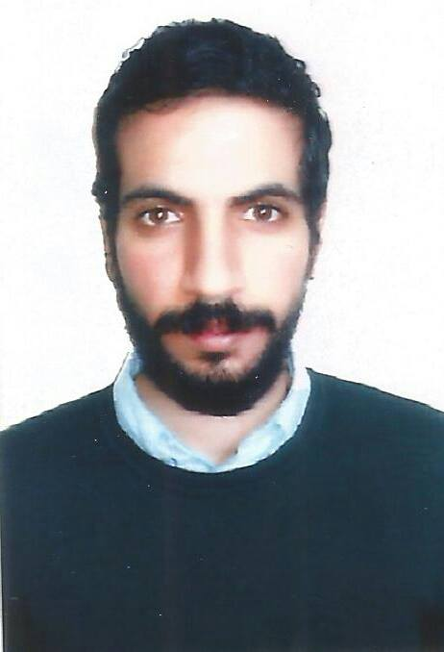
[Ali]
[UNION-METRO STATION] | [DUBAI, UAE] |
| [ ali.374801@2freemail.com ]

Objective
To obtain a position that will enable me to use my strong organizational skills, educational background, and ability to work well with people. And also maximize my Knowledge and skills.

Education
• [Faculty of commerce, Alexandria, Egypt]
• [Bachelor] | [2014]
• [Major: Accounting]

Experience
• [Sutherland Global Services (du account)] | [Alex, Egypt]

Customer services Representative (Front office) [Sep 2016] – [May 2017]
- Certified as Front office agent in Consumer and Enterprise Mobile.
• Giving information and support for Technical and billing cases.
• Handling VIP Customers, Technical Issues and internet services issues.
Outbound Customer Service Representative [May 2016] – [Nov 2017|
• Selling products and offers for different campaigns represented by the client.
• Utilize computer technology to handle / dial high call volumes.
• Top performer for 4 months on a row by achieving the targets and selling criteria's.

• Al-Safwa for real estate (DES 2015 – SEP 2016)

Realtor - SELL THE BUILDING THROUGH THE RECEIVED CALLS
• Officers Affairs Branch (Military Western Region) (Dec 2014 – Dec 2015)

Chief Information Officer - Responsible for organizing, storing and processing of personal data for each officer who served in the western region area and send data to the administration in Cairo.

• Shabab el mostaqbal school (Feb 2009– Oct 2013)

Primary English teacher - develop and foster the appropriate skills and social abilities to enable the optimum development of children, according to age, ability and aptitude.

S K I L L S
• Computer Skills: Microsoft Office: Word, Excel, PowerPoint, and Commercial Excel
• Language Skills: Excellent command of English, both written & spoken
• Learning fast.
• Excellent communication skills.
• Ability to work independently.
• Ability to work in teams.
• Ability to lead the teamwork.
• Self motivated

Personal Information
• Date of birth: Apr, 4, 1992.
• Nationality: Egyptian.

Hobbies
• Listening classic music, reading Egyptology and historian books.
• Browsing internet social websites and news sites.
• Part time volunteer at Resala charity association.
• playing football, chess and swimming.
• References Furnished upon Request.

