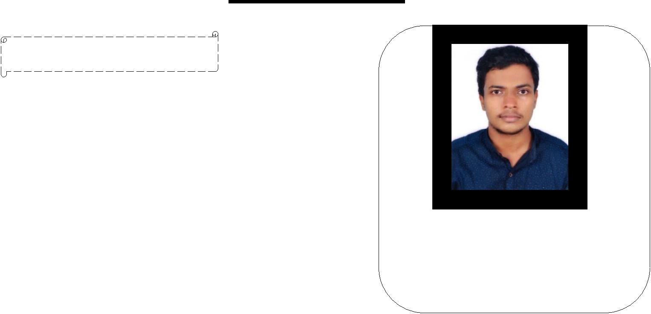
CURRICULUM VITAE

CAREER OBJECTIVE:

A career in a reputable organization | with
challenging opportunities for growth | and

shouldering responsibilities in any suitable position to prepare for emerging advances with intent to serve the company.
 | PERSONAL SUMMARY: |  |  |  |  | ZIYAD
• A motivated |  | Pharmacy graduate with |  |  | high | email: ziyad.374808@2freemail.com
 | enthusiasm for healthcare management, industry
 | oriented analysis as well as |  |  | marketing | in |  | PCI reg.no:60104
 | pharmaceutical field. |  |  |  |  |  | Visa status :Visiting
• Experienced in conducting & organizing programs
 | and leading team.
 | EDUCATIONAL QUALIFICATION:
 | Sl.No. | Subject |  |  | Institution |  |  | Academic |  | Percentage
 |  |  |  |  |  |  |  | year |  | of marks
 | 1 | B.PHARM |  | Crescent College Of Pharmacuetical |  |  |  | 2013 -2017 |  | 64%
 |  |  |  | Sciences,Kannur,Kerala.
 | 2 | PLUSTWO |  | GHSS Cherukunnu, Kannur,Kerala. |  |  |  | 2011-2013 |  | 70%
 |  | SCIENCE
 | 3 | SSLC |  | GHSS Cherukunnu, Kannur,Kerala. |  |  |  | 2010-2011 |  | 72%
WORK EXPERIENCES:

- Worked as Trainee Pharmacist in AKG Memorial Hospital,Kannur,Kerala.

- Worked as External Consultant with Kerala Health Care Study under IFMR-LEAD(Institute of Financial Management and Research ).
PROJECT:

B. Pharm Level: ‘A Review on Needle free Injections’ Centre: Crescent College of Pharmaceutical Sciences, Payangadi, Kannur. Under the guidance of Mr.Dileep Damodaran, Asst. Professor, Department of Pharmaceutics, Crescent College of Pharmaceutical Sciences, Kannur,Kerala.

LINGUISTIC PROFICIENCY:

Language | Read | Write | Speak
English | √ | √ | √
Malayalam | √ | √ | √
Hindi | √ | √
Arabic | √ | √
EXTRA- CURRICULAR ACTIVITIES:

- College Students Union Arts secretary In The Academic Year 2016-2017 at Crescent College of Pharmaceutical Sciences, , Kannur, Kerala.

- College Annual Magazine Student Finance Secretary (which won best third magazine award by Kerala University Of Health Sciences) In the academic year 2015-2016.
COMPUTER KNOWLEDGE:

Operating system: Windows, Softwares : MS-Office (Word, Excel, And Power Point).

CO - CURRICULAR ACTIVITIES:

Industrial Visit:

-Helios Pharmaceutical Company, Baddi, Himachal Pradesh.

- Morepan Laboratories Ltd, Baddi, Himachal Pradesh.

Conferences Attended:

- As a delegate in National seminar ( 11th March 2017) on Drug regulatory affairs :An Industrial Perspective ,at NITTE University , Mangaluru.

-As a delegate in International conference (24th and 25th November 2016) on ‘Herbal Drug Development: Challenges and Opportunities- A Global Perspective at Devaki Amma Memorial College Of Pharmacy, Malappuram, Kerala’.

Hobbies

- Soccer
- Social activities

PERSONAL PROFILE:

Date of Birth | : 7th May1995
Marital Status | : Single
Nationality | : Indian
Religion | : Muslim

ABILITIES:

- Quick learner and adaptive to new environment.
- Ability to follow-up well-defined procedures and work for accuracy.

- Ability to manage multiple tasks; work with employees, supervisors and managers.

- Ability to work independently, efficiency and accurately.

- Ability to organize and able to prioritize work load effectively.
DECLERATION

I hereby declare that the above and foregoing information are correct in the best of my knowledge and belief.

Ziyad

