Arafathullah  Dubai, United Arab Emirates  Email: arafathullah.374813@2freemail.com  POSITION APPLIED FOR:  OFFICE ADMINISTRATOR  DOCUMENT CONTROLLER | 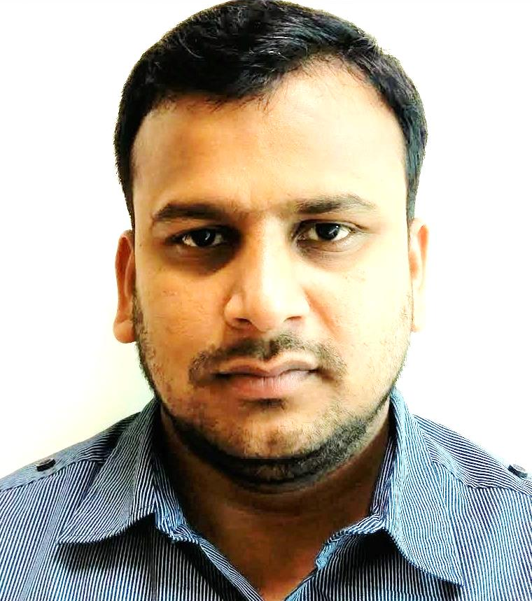
OBJECTIVES

I wish to serve a leading company that would help me to achieve my future goals with its progress. Moreover, to obtain a challenging position that would effectively utilize my extensive experienced in administrative and documentation skills at the fullest.

PROFILE

Ambitious and driven professional with almost 6 years work experiences expertise in Administration, Electronic Documentation Management System, Electronic Data Processing, Inventory Management System, Operations sector and in Tender / Proposal and Prequalification documentation.

- Ability to handle different responsibilities and follow through to completion
- Ability to effectively priorities tasks and manage a full support team
- Good team player with excellent organization and motivation skills
- Can work efficiently on own initiative or can integrate easily into a team environment
- Ability to adapt quickly to ideas, methods , environments and problem solving
- Flexible can work within many systems and settings
- Proficient with Microsoft office programs and use of database programs
- Committed and flexible to suit a varying range of tasks during the project life cycle

WORK EXPERICENCE

Worked with BK GULF LLC as an Administrator Cum Time Keeper / Document Controller in Personnel Department & FM Departments from June 2006 to June 2017

Duties and Responsibilities:
- Establish and maintain an updated database for all employees’ passport renewal, work
permit renewal and Emirates ID renewal doing are all personnel Department job.
- Establish and maintain accurate record keeping and up to date files of contracts, Amendments, pre contracts correspondence and all other documents.

- Assures all task are completed and proper documentation are followed in compliance with the approved policies and procedure for Audit purposes.

- Manage all aspects of tender documents and ensure the completeness of the documents received from the Client.

- Responsible for printing and keeping in a proper filing of all Tender documents.

- Gather data and information in order to complete the proposal/tender strategy as per client’s Krequirement and ensure that all corporate documents are well checked and submitted prior to the documents submission date.

- Preparation and completion of Pre-qualification Documents and Tender Documents, correspondence and other technical documents needed in the tender submission as per Instruction to Tender.

- Provide administrative assistance like preparation of bid tabulations records, spreadsheets and preparation of reports.

- Maintain the highest level of integrity in accordance with the tender procedure manual.
- Generates reports as required by other department, and perform other duties as assigned from time to time.

PREVIOUS EXPERIENCE

Worked with ICICI Bank, Lalpet Branch, Tamilnadu, India as a Customer Care Representative from May 2004 to June 2006.

Duties and Responsibilities:

- Check the accuracy of the data and information encoded by the Data Encoder before
processing and updating the Pharmaceutical Management System.

- Manage all filing system and ensured that all documentation is controlled in accordance
with the company’s procedure.

EDUCATION

Bachelor of Science in Secondary Education (Chemistry ) from Bharathidhasan University Trichy (Year 2001 to 2004)

COMPUTER SKILLS:

M.S. Office (Word, Excel & Power Point) and thorough knowledge in Internet & Email Systems.

TYPING SKILLS:

English Typewriting - 60 W.P.M

PERSONAL DETAILS

Date of Birth : 20 March 1981
Marital Status : Married
Nationality : Indian
Religion : Muslim
Languages : English, Hindi, Tamil and Malayalam
Visa Status : Visit Visa
Visa Expiry : 30th Jan 2017

DECLARATION:
I hereby declare that the information furnished above is true to the best of my knowledge.

Date:
Place: Arafathullah

