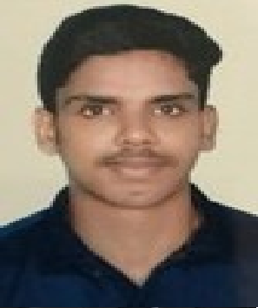CURRICULAM VITAE

OBJECTIVE

NIHAL
Email: nihal.374814@2freemail.com
To work with maximum potential in a challenging and dynamic environment, with an opportunity of working with diverse group of people and enhancing my professional skills with learning and experience for career growth.

MY PROFILE

“Young dynamic hard and smart working, result oriented”

MY SKILL SET

DUBAI UAE
Work well in a team environment.

I can work more time if it is important. Eager, honest, helpful and enthusiastic. EDUCATIONAL QUALIFICATIONS
Bachelor of Technology in Electrical and Electronics: (Cochin University of Science and Technology)
Plus two science: (MGM MODEL SCHOOL, Ayiroor, Kerala; CBSE, India)
Class 10th :( MGM MODEL SCHOOL, Ayiroor, Kerala; CBSE, India)

PERSONAL INFORMATION

DATE OF BIRTH: 04/03/1994 FATHER NAME : M A NIZAR RELIGION : MUSLIM NATIONALITY : INDIAN
GENDER : MALE MARITAL STATUS: SINGLE

HOBBIES
READING WATCHING MOVIES TRAVELLING LISTENING MUSIC
VIDEOGRAPHY&PHOTOGRAPHY

PLAYING CRICKET

PERSONAL SKILLS
SPECIAL ABILITY TO MINGLE WITH PEOPLE.
CREATIVE MIND. WILLINGNESS TO LEARN C LANGUAGE.

CERTIFICATIONS IN

MECHANICAL AND ELECTRICAL PLUMBING

ORGANIZATIONAL EXPERIENCE (10 Months)

ASSISTANT MANAGER AT GMR CERTIFICATIONS Inc. Kerala, India (2017)

JOB RESPONSIBILITIES

- Preparing Incident Report Sheets, Monthly Performance Reports along with various Maintenance Strategies.
- Perform daily issues monitoring, assigning the concerned dept, maintaining the call records
- Daily, weekly, monthly preparation of all maintenance status update reports and forwarding the same to client
- Maintaining tracks for each Job & following with concerned departments
- Schedule daily workload ensuring the work is prioritized and that work is completed expediently and professionally. .

AUTOCAD 2D.

ELECTRICAL CAD.

OFFICE EXCEL, WORD, PUBLISHER &
POWER POINT.

PASSPORT & VISA DETAILS

PASSPORT VALIDITY:06/08/2027 PLACE OF ISSUE: TRIVANDRUM VISA STATUS: VISIT VISA
VISIT VISA VALIDITY: 18/01/2018

LANGUAGE SKILL

  - English , Hindi, Malayalam, Tamil

DECLARATION

I do here by declare that all the information and details mentioned above are true to the best of my knowledge and belief.

Place: Dubai NIHAL

