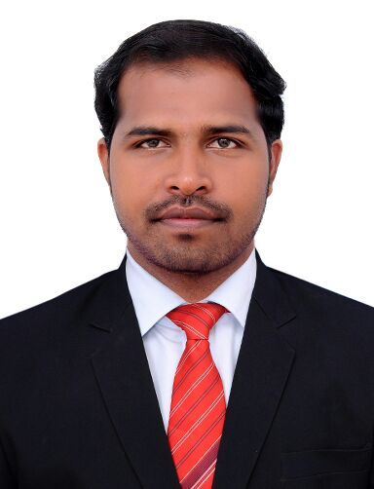
CURRICULAM VITAE
RATHISH
E-mail: rathish.374816@2freemail.com
Dubai
Visit Visa, valid 25th Dec 2017

Summary
An enthusiastic, motivated, loyal, and dependable Executive with extensive experience. Demonstrate strong skills in HR Administration, Recruitment, time management, prioritizing tasks, and meeting deadlines. Able to prioritize effectively to accomplish multiple tasks and complete projects under pressure. Highly trusted to maintain strict confidentiality regarding staff details, human resource functions and sensitive business decisions.

PROFESSIONAL Experience
1. INAUTIX TECHNOLOGIES - 3 YEARS Apr' 14 - July' 17
HR Admin & Recruitment Executive Chennai, India.

Administration:
- Accurate input and maintenance of information about the employees details such as name, date of birth, joining date, and similar details.
- Facilitate monthly payroll activities and tracked in the system.
- Maintain financial file records.
- Maintain current HR files and database.
- Preparing leave settlement and end of Service settlement of employees.
- Informing employees about their daily work schedule and shifts.
- Supervise routine Office Administration works such as allocation of office space and provision of furniture and stationary.
- Maintain leave records of employees by recording and administering regular activities and forwarding to H.R Manager. Maintain the leave management system.
- Arranging and coordinating the transportation facilities for the employees.

Recruitment:
- Handling end to end recruitment for IT agent level requirements.
- Responsible for sourcing candidates from various mediums like manpower consultancies, training institutes, job portals, and internal database, bulk SMS/mails and employee referrals.
- Generating offers through the practices like insertion of paper pamphlets, distribution of notices.
- Getting reference from the candidates and ensuring maximum resource utilization.
- Organize campus drives and outstation recruitment to meet the recruitment numbers within specified lead-time.
- Screen the candidates through telephonic interviews, written tests and direct interview.
- Manage database to document the process of hiring & placement.
- Vendor performance & management.
- Increased the consultancies database. Found many new consultancies to close the requirements on time.
- Verification of the invoices raised by the vendors and forwarding the same to the accounts department for the smooth processing of the payments.
- Verification of all necessary documents.

2. STANDARD CHARTERED BANK - 2.5 YEARS Nov' 11 - Apr' 14
Operational Officer Chennai, India

- Applying Credit and debit to the customer account.
- Responsible for checking customer's identification to verify the customer account.
- Promptly responded to the general enquiries related to the customer's account information and providing answer to their questions.
- Balancing the account at end of the day.
- Communication with other bank regarding short and excess claims and clear the issue.
- Tracking query related email and solving the issues.
- Handling reconciliation and resolving the problem.
- Achieve best results in every month end business reports in accordance to the goal of the bank.
- Show good values and right conduct among their people for better work relationships.
- Responsible for providing the current and savings account balance details to customers and cash checks for them.
- Record all transactions correctly and in compliance with bank guidelines.

KEY SKILLS
- Good Administrative and IT skills such as MS Outlook, Word, Excel, PowerPoint.
- Trustworthy and discreet.
- Team working and supporting colleagues.
- Patience, Integrity and sensitivity
- Flexible and adaptable.
- Quick Learner

EducationAL QUALIFICATIONS
Loyola College, Pondicherry University
Master of Business Administration (MBA)
Completed MBA in First class from Loyola College, Pondicherry University, Chennai, 2015 in India.

Sathyabama University
Bachelor of Science in Computer Science (B.Sc)
Completed B.Sc Computer Science in First class from Sathyabama University, Chennai, 2011 in India.

PERSONAL INFORMATION
E Mail id : rathish.374816@2freemail.com
Marital Status : Single
Date of Birth : 08 April 1991
Nationality : Indian
Languages Known : English, Tamil and Malayalam.
Visa Type : Visit Visa

DECLARATION
I do hereby declare that the above-furnished information is true to the best of my knowledge.

Date: ________________
Place: Rathish

