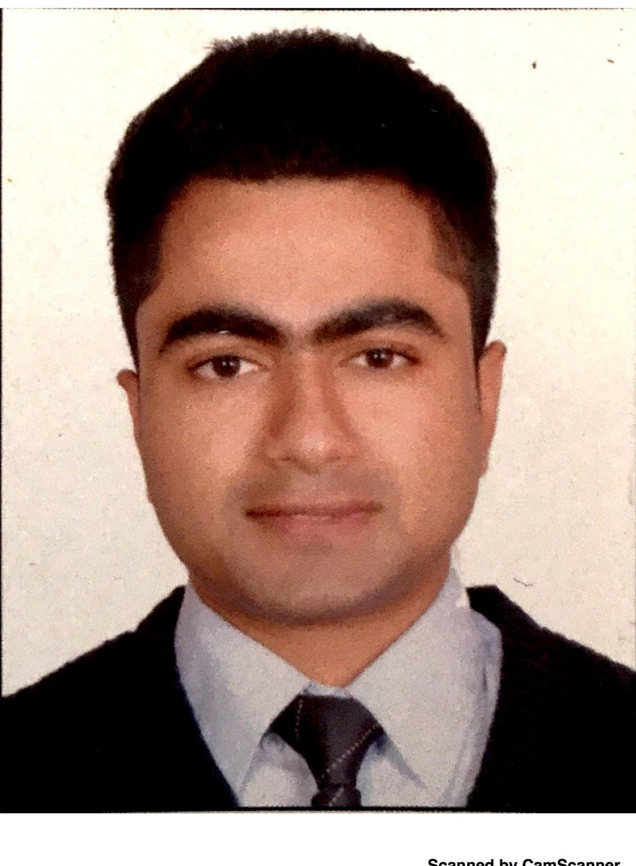
RESUME

Email​​​​​​​:​​ sachin.374833@2freemail.com

Name |  | : Sachin​​
Sex |  | : | Male
Date​​Of​​Birth |  | : | 12/09/1992
Marital​​Status |  | : | Single
Driving​​License |  | : LMV​​+​​Two​​Wheeler.
Passport​​Details
Issue​​Date |  | : | 28/03/2015
Expiry​​Date |  | : | 27/03/2025
Place​​of​​Issue |  | : | Cochin.

An enterprising young candidate seeking a responsible and challenging position in a reputed firm where my education and background will be of value, expand my knowledge, and offer opportunities​​for​​personal​​&​​professional​​growth.

A.​​​IndiGo​​Airlines
Airport :Kempegowda International Airport,Bangalore

Designation :​​Customer​​Service​​Officer
Period​​Of​​Working :​​11-Aug-2016​​to​​03-May-2017

Work​​Description
- Delivering​​the​​highest​​level​​of​​Customer​​Service​​at​​all​​customer​​touch​​points

- Constant​​liaison​​with​​Check-in,​​Boarding​​Gate,​​Ramp,​​Cargo,​​Lounge

- Supervising service partners activities for the smooth acceptance of passengers

- Directing Arriving/Departing passengers to respective areas such as Arrival Hall,​​Transfer​​Area,​​Departure​​Gate,​​Lounge,​​etc

- Handling​​baggage​​claims

- Ensuring​​compliances​​with​​OR​​safety​​an​​security

- On​​Time​​Performance

​​B.​​​Max​​Car​​Care​​–​​Kottayam,​​Kerala
 | ​​​​​Position​ | :​​​Admin​​&​​Customer​​Relations​​Officer​.
 | ​​​​​Period​ | :​​​November​​2012​​–​​August​​2014
Work​​Description
- Database​​Management
- Sales​​inward​​&​​outward​​accounting.

- Coordination​​with​​major​​automobile​​dealership​​&​​Body​​shop.

- Lodging​​insurance​​policy​​with​​insurance​​companies.

Bachelor​​of​​Business​​Administration​​in​​Aviation.​​​​​​(2012​​​–​​2015)
Aptech​​Aviation​​Academy​​–​​Cochin.

- Was​​a​​part​​of​​4x4​​extreme​​jeep​​off​​roading​​club​​conducted​​in​​kerala
- Won​​prices​​in​​roller​​skating​​championships

- Was​​a​​part​​of​​school​​cricket​​team​​in​​2009

- Attended​​bicycle​​championship​​in​​high​​school

- Badminton​​player

Office​​Automation ​​​:​​MS​-Office.

​​​Speak :​​​English,​​​​Hindi,​​Tamil​​&​​Malayalam.
Read​​​&​​​Write :​​​English,​​​Hindi​​&​​Malayalam.

Declaration:

I​​hereby​​declare​​that​​above​​information​​is​​correct​​to​​the​​best​​of​​my​​knowledge​​&​​belief

