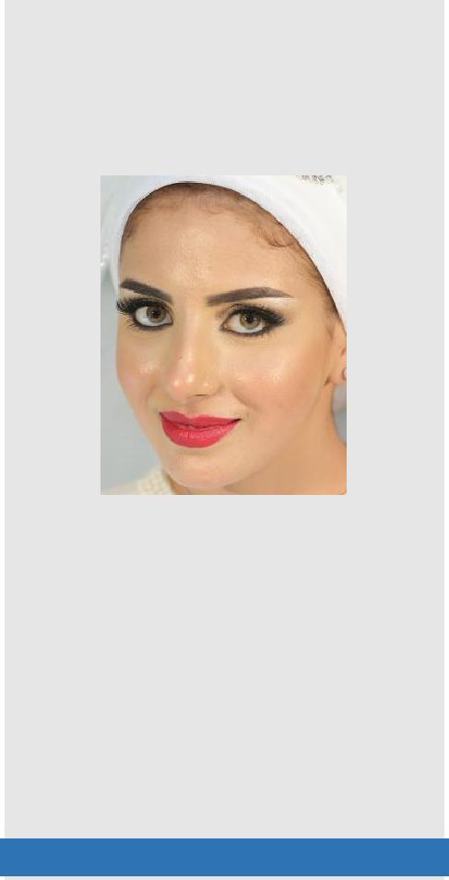

Email: esraa.374841@2freemail.com

ABOUT ME

Birth Date: 23 Oct. 1991

Visa Status: Can be transferred

Esraa
Telecommunications & Electronics Engineer
Objective

To obtain a full-time position in technology and communications field within a supportive and growing environment so i can contribute to the organization success while using and enhancing my professional skills.
Education

- BS (Electronics and Telecommunication) From Shorouk University in Cairo, Egypt, in 2015.
EXPERIENCE

IT Engineer (Sep 2015 To Present)
American International School in Dubai (AIS)
Job Description:

- Setting up the school's educational software on students and teaching stuff devices.

- Handling with the educational application and solving all problems related to it.

- Programming some algorithms that is needed to be dragged into systems and applications.

- Integrating proper solutions revolving around different modes of communication and information transfer.

- Maintaining all equipment in the school.

- Developing the web site regularly.
Post Graduate Trainings

- Team Assist. In Motorola at Smart Village.

- Technical support Vodafone Eg at Smart Village.

- Technical support in Etisalat at Smart Village.

- VHDL Team member in Mentor Graphics.

- Fiber Optics team assist at Heliopolis local central.

- Android Apps team member in 3-Hands.

- Location update service team assist. In Vodafone Eg at Smart Village.

Courses

- Mobile Package (All generations)

- Java for Android Introduction

- Java SE

- NA

- C++ Language

- C Language

- Micro Controller 1

- Micro Processor 1

- Orcad Introduction

- Fiber Optics principals

Articles

- Android Jam Application (Complete System) as a GP.

Skills

- An understanding of electrical health.

- Creativity, innovation and attention to detail.

- Strong analysis and practical problem-solving abilities to improve Solutions.

- Oral, written and diagrammatic communication skills, with the ability to translate complex ideas into clear concepts.

- The ability to work in a multidisciplinary team with other engineers;

Languages

- Arabic: Mother tongue.

- English: Very Good.

- French: Elementary.

References

- Available upon request.

