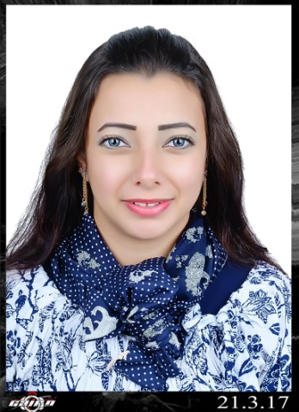
Curriculum Vitae
Shimaa.374860@2freemail.com

Personal Data :
Name : Shimaa
Nationality : Egyptian,
Marital Status : Single,
Religion : Muslim,
Education :
Secondary Commerce School,
Language:
Arabic Mother Tongue English (Excellent) Russian (Intermediate)
Computer skills:
Windows xp 7 / Microsoft office / Internet,
Personal Skills:
Flexible in dealing with different nationalities- Quick learning -Active - Owner ship -
Good communications -Work under pressure
I am Able to do
- (Aromatherapy, Swedish, Shiatsu, Deep Tissue, Foot reflexology and Thai Massage)
- Body scrub, Body treatments, Body wrap and Facial Treatments

Working Experience
- Therapist at Horse Spa Hurghda , Red Sea ,from 2009 till 2010,
- Therapist at stars Group Makadi bay, Red Sea from 2010 till 2015,
- Therapist at Tarvco Hurghada , red Sea from 2015 till 2016,
- Therapist at Rehana Hotel and Resort Elgona Red Sea , from 2016 till 2017
- Therapist at Hilton Double three UAE from January till october 2017.

