AREAS OF EXPERTISE
Telecommunications
Networking
Electronics
Projects
Projects Of
Engineering
Manufacturing

Maintenance and Repair
Fault Diagnosis

Customer Service

Digital Communication
Project cost estimation
Safety Compliance
Project management
Process improvements

Hardware
CAREER STATEMENT
“Apart from contributing to
the processes and strategies
which enhance any projects I
am working on, I feel that my
greatest strengths are firstly
my ability to deliver projects
to agreed timescales.
Secondly my skill at gaining a
clear understanding of a
clients exact needs, and
thirdly being able to co-
ordinate and lead all team
resources whilst at the same
time building strong working
relationship with fellow
colleagues and thereby
getting them to improve their
performance.“
Mohd Aamir kaloo
Aamir
Electronics & Communication Engineer

PERSONAL SUMMARY
An enthusiastic and highly motivated individual who has a clear understanding of
the role and responsibilities associated with being a E&C engineer. Having the
ability to provide support for multiple concurrent priorities, I amable to
establish, maintain and develop effective working relationships with service users,
operational teams, delivery partners and colleagues. possesses a broad range of
technical, personal effectiveness and leadership skills and uses rigorous logic and
methods to come up with effective solutions to difficult problems. As someone who
is comfortable with and able to effectively cope with change,I have a long track
record of making best use of any available resources and techniques. I am
currently looking for a suitable position with a ambitious company where i will
be working with industry experts, people who have the skills and experience to
make a real difference to my future.
CAREER HISTORY
Shah Ji Constructions– India
Site Engineer
- Responsible for Site to Site Fiber testing by OTDR & Traces save and Trace
submit in Office.
- Responsible for FRT (fiber rectification test) and LSPM (laser source power meter).
- Responsible for NI(node insert) and Tapping (existing route),Splicing (16F, 96F & 288F)
fiber cable.
- Surveying.
- HOTO (handover takeover)

- Kutumbh Care (Reliance Jio Infocomm Limited 4G Project)–India

Fiber Engineer November 2014 – March 2016

Project Implementation/Installation/Operation/Maintenance of O.F.C and various Telecommunication Equipments used in the Network infrastructure. Responsible for Site to Site Fiber testing by OTDR & Traces save and Trace submit in Office. Responsible for FRT (fiber rectification test) and LSPM (laser source power meter). Responsible for NI(node insert) and Tapping (existing route),Splicing (16F, 96F & 288F) fiber cable. Coordination NOC and O&M, Planning Team. Monitoring OFC and Jointing. Planning and survey of laying route. Responsible of all types of document such as related to billing, material reconciliation ,MB sheet, ABD (as built drawing).

Project Work :-

- Automatic Street Light
- GSM Controlled Land Rover with Visuals Using Team Viewer

Internship:-

- Industrail Training (6 weeks) at Ericson Telecom Solutions,Srinagar (J&K)

.

April 2016 – November 2017
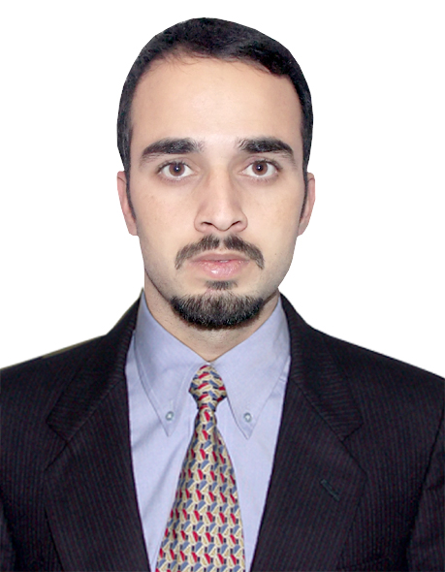

E:aamir.374892@2freemail.com
Expiry date :- 09/06/2026
Visa Type :- Visit Visa (90 days)
Visa Expiry date :- 20/02/2018

Nationality: Indian
DOB: 05/03/1993
PERSONAL SKILLS
Inventiveness
Disciplined
Self-motivated
Interpersonal sensitivity
Persuasiveness
Awareness of ethical
issues
Practical, methodical,
and accurate
Able to make good
judgements
Creativity
KEY SKILLS AND COMPETENCIES
Electronics and Communication Engineering attributes

• Knowledge of contract technical specifications and their implementation.
• Able to Prioritize Individual workloads according to deadlines.
• Knowledge of computer-assisted engineering and design software.
• Establishing sub-system response to component failures.
• Excellent fault finding and diagnosis skills..
• Able to read electrical design specifications and technical drawings.
• Keeping up to date with the latest developments in technology and regulations.
• Ability to control multiple project activities simultaneously.
• Assessing the environmental impact and risks connected to projects.
• Able to explain technical issues to non technical customers and colleagues.
• Undertaking electronic sub-system problem investigation.

Professional attributes

• Able to check the work of others & supervise less experienced or junior staff.
• Pricing, quoting and resourcing work within delegated authority levels.
• Writing accurate technical reports.
• Computer literate and conversant with MS Office suite and relevant engineering
software packages.
• Assisting with competency appraisal processes for junior staff.
• Capable of defining and leading assignments.
• Always willing to help other less experienced team members with workloads.
• Supporting any procurement processes.

Personal attributes

• Good communication, planning and organisational skills.
• Highly developed numeracy and computer literacy skills.
• Self motivator and the ability to motivate others.
• Keeping up to date with industry best practice.
• Able to work on your own initiative as well as being a team player.

ACADEMIC QUALIFICATIONS

Three Year Diploma in Electronics & Communication Engineering.

Simtech Certified in Telecom Infrastructure Engineering.

Diploma in Information Technology.

CCNA (Cisco Certified Network Associate) Training Certificate.

Intermediate.

REFERENCES - Available on request.
PROFESSIONAL

