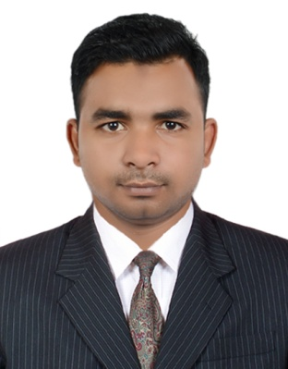
ABU | E-mail: abu.374900@2freemail.com
Career Objective :

To become a dynamic professional through seeking challenging works and sharpening my managerial skills by working in competitive environment.

Educational Qualification:

Name of the course | University / Board / Institution | Principal Subjects | Year of Passing
MBA | Bangalore university / Presidency College | Marketing/Finance | 2014
B.COM | Veer kuwar singh / AL hafeez college | Account | 2012
Class XII | Nation institute of open school | --- | 2009
Class X | Central board of secondary education | --- | 2007

Technical Skills/Computer Proficiency:

Others: MCSE, CCNA, MS Office.

Work experience or corporate training:

worked with Nestle Waters Company as a sales supervisor (Dubai, UAE) Since 28 December 2015 to 30 November 2017.

Job responsibility
- Understand customer needs and offer solutions and support
- Organize and coordinate sales representatives schedules
- Research potential leads from business directories, web searches, or digital resources
- Train new sales representatives
- Receive and report on all sales leads
- Supervise sales representatives and assistants
- Answer potential customer questions and follow-up call questions
- Work with sales team when closing sales
- Track weekly, monthly, and quarterly performance and sales metrics
- Meet all sales quotas and goals
- Assist sales representatives and team to meet and exceed goals

Worked for BIG BAZAR form 10.07 2014 to 25.08.2015 as a DAPARTMENT MANAGER .

Job responsibility
- Inspect merchandise to ensure it is correctly priced and displayed. Prepare sales and inventory reports.
- Assist sales workers in completing difficult sales.
- Recommend additions to or deletions of merchandise to be sold in department.
- Train workers in store policies, department procedures, and job duties.
- Maintain stock, supplies and inventories.
- Maintaining exceptional customer service.

INTERNSHIP at Viashal Patliputra Dugdh Utpadak Sahkari Sangh LTD, Phulwari Sharif, Patna, BIHAR.

DURATION: One month

Seminars / Symposiums attended

Seminar at IIM Bangalore. 2013

Achievements/ Extra Curricular Activities:

Personality Traits: Disciplined, Good team player, punctual, Quick Learner

Area of Interest: Marketing, Healthy arguments, Think out of the box

Sports
- I Represent state and district cricket team of Bihar
- I was the captain of my school team.
- I was the man of the series in dehradun T2o champion Trophy
U.A.E Driving license Number (MANUAL): 3716487

Personal Details:

- Date of Birth : 19 July 1992
- Sex : Male
- Marital Status : Unmarried
- Nationality : Indian
- Religion : Muslim
- Language - Can Write : English, Hindi,
Can Speak : English, Hindi, Urdu

Date: Signature

