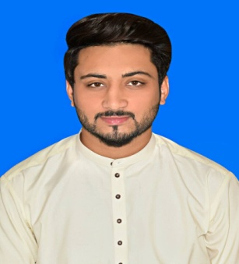
Salam
Email: | Salam.374903@2freemail.com
Objective:
“A committed and driven BS Electronics Graduate with a sound understanding to work in an environment which encourages me to succeed to grow professionally where I can utilize my skills and knowledge appropriately”.
Work Experience:
Worked as a lab Engineer in Federal Urdu University Islamabad Pakistan for 1 year. The duties I perform as a lab Engineer is:
- To maintained the lab equipments
- To performed electronics projects with the students
- To Organized and Managed Open house
Education and Qualifications:

BS Electronics | 2013 – 2017 Comsats Institute of Information Technology Islamabad.
F.Sc | Pre- Engineering 2012 Cadet College Palandri AJK
Matric | Science 2009 Cadet College Palandri AJK

Graduate Projects:

- Object Oriented Programming
Built a simple calculator using C++ using eclipse
- Micro-Processor
Built power supply
- Electronics
Designed an Audio Amplifier
- Real Time Embedded System
Designed filters High pass, Low pass, Band pass and Band stop using MATLAB
- Antenna and wave Propagation
Designed different antennas in HFFS
- Circuit Theory
Circuit designing and implementation
- Final Year Project
Designed and implemented of walking aid for impaired people. Blind Aid helps in the movement of visually impaired/blind people by using an electronic device which is very accurate. It uses ultrasonic sensor (HC-Sr04) through which distance of any upcoming object in front of user is measured and it provide feedback through sound. Ultrasonic sensor is activated and controlled through microcontroller PIC18F2550. It is a multi-functional device which operates for obstacle detection and depth onward. 1st Position in Open House Exhibition, 2016 as rewarded by Research Head of Atomic Energy, Nilore Islamabad.

Curriculum Activities:
- Attended workshop on “Productive language skills and their importance “.
- Attended seminar on “Entrepreneurship “
- Organized Open House for project display.
- Secured first position on the final year project displayed at the ‘Open House”.

Key I.T. Skills:
- Microsoft Office | - MATLAB
- HFFS
- Proteus
- PIC18F2550 Microcontroller
- HC-SR04 (Ultrasonic sensor)

Strengths:

- Confident and Disciplined
- Time management and team leadership
- Hardworking and Energetic
- Keen to learn new things
- Good communication skills

Personal Data:
Age : 25
Birthday : 26/06/1992
Marital Status : Single
Nationality : Pakistan
Visa Status : Visit visa

