Hansraj
E-Mail: hansraj.374907@2freemail.com
Data Entry Operations
(Client Partner )

Core Competencies  Data Entry Operations  General Administration  Data Analysis  Reporting & Documentation  Client Relationship Management  Team Management |  | Profile Summary  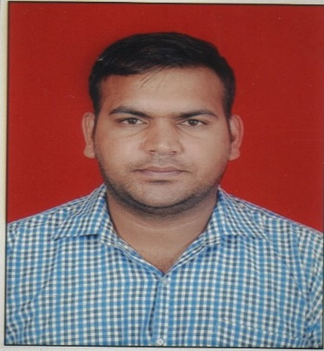  - Result-oriented professional with nearly 3 years of experience in Data Entry Operations and General Administration  - Expertise in preparing documents related to quality with a view to apprise management of process operations and assist in critical decision-making process  - Proven capability in maintaining requirements by following data program techniques and procedures  - Proficient in creating and maintaining reports for allowing the company to get information on daily business activities  - Experienced in designing reporting formats to provide accurate information in a clear and concise manner as well as producing and supporting existing reports and processes  - Gained exposure in medical terminology, telephone administration, office management, software administration and customer service  - Possess excellent communication, relationship management, team building and analytical skills

Organisational Experience

Access Healthcare, Pune Since Sep’16
Data Entry – Client Partner

We Sales Leads, Pune Jan’14 – Jun’16

We sale leads nov 2017 current
Data Entry Assistant ( client partner )

Key Result Areas:
- Conducting surveys and collecting data through interviews & questionnaires
- Contributing to improve customer satisfaction & relationship between company & clients
- Storing medical information electronically which improves speed, quality, safety, coordination & cost of patient care
- Answering phone calls and resolving problems with orders
- Managing confidential information in line with the companies security protocols; maintaining customer confidence by keeping files, documents & other information (patient’s fax number & phone number) confidential
- Meeting, greeting and attending clients at reception desk according to their needs
- Answering phones, keeping a calendar & arranging appointments with clients

Highlights:
- Verified accuracy of data before it is entered
- Located and corrected data entry errors
- Sorted and arranged books into different categories

Academic Details

- M.Com. from University of Pune, Pune in 2013
- B.Com. from University of Pune, Pune in 2011

Personal Details

Date of Birth: 05th January 1988
Languages Known: English, Hindi and Marathi

