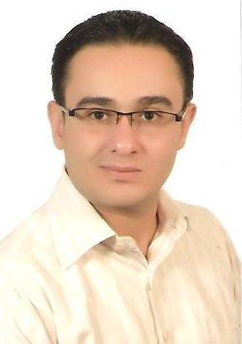
Ahmad
Email: ahmad.374909@2freemail.com

OBJECTIVE
Engineer-in-Training (FE) with 5+ years’ experience specializing in HVAC system design. Strong proficiency in engineering drawing interpretation. Adept at functioning well both as a team member and independently.

PROFESSIONAL EXPERIENCE
DAMASCUS university at technical office since 1/1/2011 to 1/1/2017
Balbaki co.Syria Damascus bab mosala square as trained 2010
Syral for Aluminums Extrude Damascus2008 - 2009
Prepared engineering design drawings including specifications, equipment schedules and HVAC layout design.
- Conducted field investigation for piping systems and HVAC equipment at various customer facilities.
- Assisted PE’s with HVAC design, performed load calculations, and selected appropriate equipment.
- Experience in HVAC software HAP& AutoCAD.
- Design & supervisor construct of solar system of hot water in students resident of Damascus university
- Supervising maintenance and operation of heating and air conditioning equipment
Supervisor of maintenance of split Air Conditioners in Damascus university & repair
failures & change Spare parts for it.
- Design & supervisor construct of Systems of Fire-fighting & Maintenance of Equipments( dry &wet systems foam & powder water bump & pipes ext…..)

EDUCATION
Bachelor of Science in Mechanical Engineering (GPA3.0) 2008 University of Aleppo, Syria

PROFESSIONAL DEVELOPMENT
▪2011 Training course in HVAC systems Damascus Engineers Syndicate
2012 Training Course in Systems of Fire-fighting & Maintenance of Equipments, Syrian civil defense
2013 Training Course in the Design of Fire Alarm Networks, Damascus Engineers Syndicate

SKILLS
- Engineering: TRACE 700, HAP v4.90
- CAD: Autodesk Revit, SolidWorks
- MS Office: Excel, Word, PowerPoint, and Outlook

PERSONAL INFORMATION

Nationality: Lebanese , and Syrian
Date of Birth: 1st of Jun 1983
Military service: completed
Status: Single
Hobbies: International Travel, Reading, Football
Email: ahmad.374909@2freemail.com

