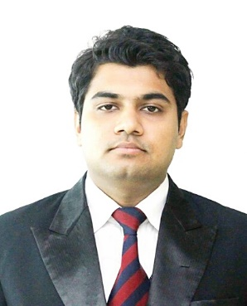
FAIZAN

D.O.B.: 14-May-1994
Nationality: Indian
Email: faizan.374913@2freemail.com

PROFILE
I have completed my MBA in Marketing and HR (double major). I have more than 1 year of experience in Sales, Marketing and Customer Relationship Management.

OBJECTIVE

Looking forward to secure a career opportunity with an organization to gain knowledge and experience from challenging avenues and utilize the best of my competency, management and administrative skills for mutual growth and success.

EDUCATION
Amity Global Business School, Amity University, Kolkata, India
MBA – Marketing and HR (double major), May 2016. CGPA – 7.69
BBA – Marketing and CRM, May 2014. CGPA -7.74
Class X – ICSE 80%
Class XII – ISC 72%

LANGUAGES

English – Excellent reading, writing and speaking
French – Intermediate reading, writing and speaking
Arabic – Intermediate reading and speaking

SPECIALIZED SKILLS
- Excellent interpersonal and communication skills
- Multi-tasking abilities with proficiency in organizing and managing different tasks
- Expert knowledge of handling administration and paperwork
- Excellent at competition analysis
- Excellent team management skills
- Proficient in stress, time and performance management
- Fast learner, engaging and self-motivated
- Creative sales & marketing skills to promote business
- Professional query resolution and problem solving skills
- Computer Skills - Microsoft Office suite and Microsoft Operating Systems

PROFESSIONAL EXPERIENCE

- Marketing and Sales Manager, Visionex Optics Pvt. Ltd. (Jan, 2017-present)
Ophthalmic lens manufacturing company.

Responsibilities and Role details:

- Designing strategic business plan to expand company’s customer base.
- Achieving growth and hitting sales targets by successfully managing the sales team.
- Implementing and administering performance management processes.
- Presenting revenue expenses reports and realistic forecasts to the management team.
- Identifying emerging markets and presenting graphs on market shifts and competition.

- Executive (Marketing & Sales), Tata Teleservices Ltd. (Jun-Sep 2016)
Tata Teleservices Ltd. is a leading telecommunication company in India.

Responsibilities and Role details:

- Worked as company representative and increased the ROI through channel and retail development.
- Monitored competition by providing market intelligence report.
- Retained clients through detailed product communication and benefits.
- Gathered information for performance analysis and highlighted progress gaps.
- Focused on branding to build brand awareness while managing marketing campaigns.

AWARDS AND INTERESTS
- Best Leadership Quality Achievement Award and Best Human & Traditional Values Prestigious Award.
- Hosting varied events and conducting seminars round the academic calendar.
- Honored as the Chair Person of the Debate Society and winner in various co-curricular activities.
- Active participation in Green [O]x event for environment safety measures & awareness.
- Reading books on different genres, making presentations on varied topics of business and economics, playing table tennis, blogging, poem and story writing.

THANKS

FAIZAN

