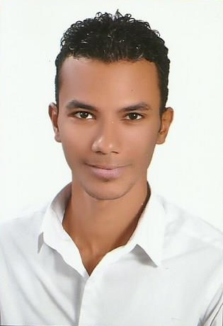 Elbendary

Personal Information
Address: Alnahda, Dubai.
E-mail Add.: elbendary.374914@2freemail.com
Gender: Male.
Nationality: Egyptian.
Date of Birth: 13/02/1990.
Marital Status: Single.
Driving License: GCC& Egypt.

___________________________________________________________________________

Objective
Seeking aposition of civil engineer and a challenging assignment with a reputed company to utilize acquired skills and knowledge and achieve predefined objective.

___________________________________________________________________________

Education
Degree: B.Sc. in Civil Engineering, Faculty of Engineering,
Alexandria University, Egypt (2013).
Grade: Good (70.20%).

___________________________________________________________________________

Graduation Project

Name of Project: Design of Steel Structure.
Project Summary: Design for all elements of factory frame consists of two cranes,
Office frame consists of two storeys and Bridge linking the
Office frame with another office frame and factory frame.
Made all the details drawings for each part of the project.
Grade: Excellent.
___________________________________________________________________________

Fields of Experience
Marseillia Group April 2017
Jop title Site engineer (Marseillia beach 4 project)
Job Summary: - Concrete works.
- Finishing Works.
- All correspondence/documentary with consultant.

Ghazay Daif Allah Al-Harbi Est. (Saudi Arabia) April 2014
Job titl: - Site engineer (Water networks implementation project stage7 at Alqassim region 2014:2016)
- Project manager (Water pipelines project at Shaqra governorate 2016:2017)
Job Summary: - Water networks implementation.
- Excavation and back filling works.
- Pavement works.
- All correspondence/documentary with consultant.

August 2013 Behera Company
Job title: - Site engineer (Alsaraya royal plaza building)
Job Summary: - Concrete works
- Finishing Works

April 2011 Talaat Mustafa Group.
Training Summary: Trained in Sewage treatment unit construction El-Amrya.
_____________________________________________________________________

Languages
Arabic Mother tongue.
English Good.

_____________________________________________________________________

Professional Courses
Structural design Diploma.
BIM Diploma.
___________________________________________________________________

Computer Skills
Engineering Software: Autodesk AutoCAD 2013.
Autodesk Revit 2015.
CSI Coulmns.
Primavera P6.
Sap pro vol. 15.

Other: Microsoft Office 2013.
Windows & Internet.

____________________________________________________________________

