MUSA
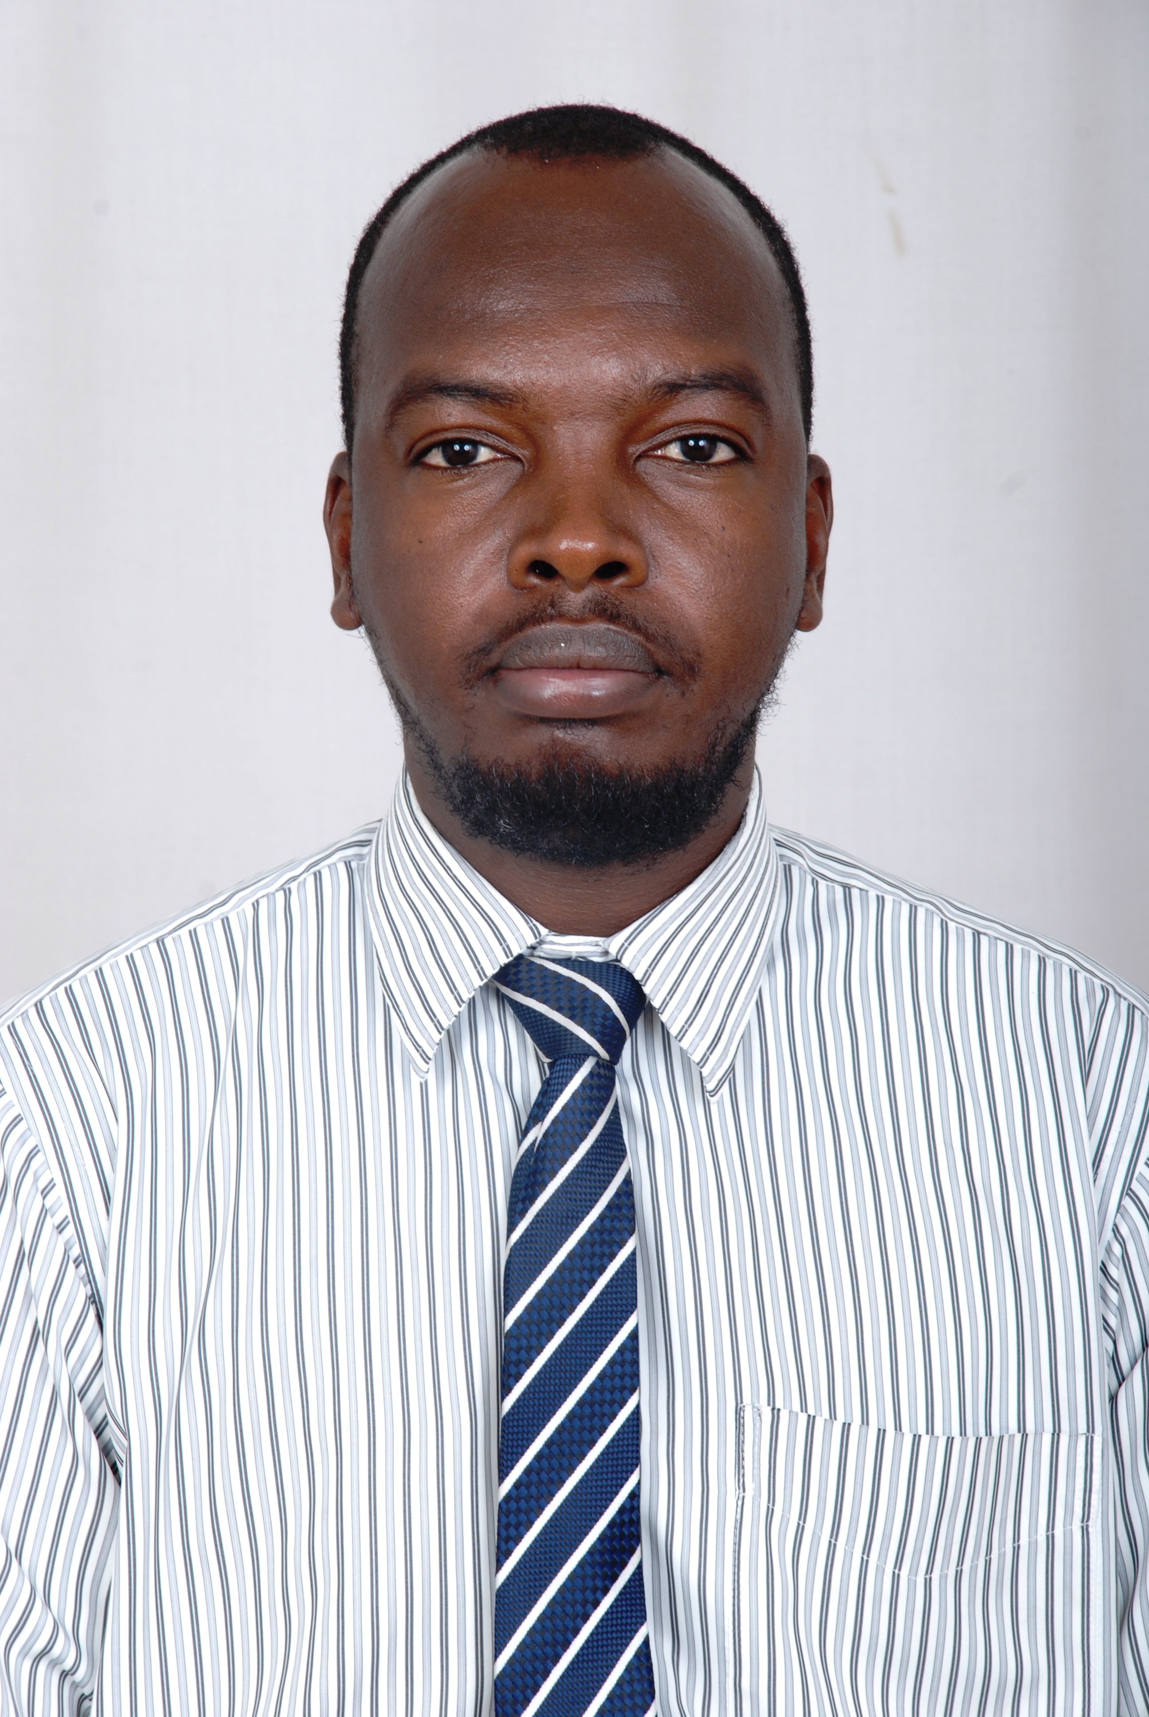
Musa.374941@2freemail.com

Objective

To enhance my skills to pursue my carrier in the competitive environment by making significant contribution to any reputed grooming organization related my experience.

Professional Experience

- BAIRAQ AL EZZ CONTRACTING COMPANY in Sultanate of Oman as a Civil Engineer from 01/08/2008 to 09/11/2009.
- AL MALAKIE BUILDING CONTRACTIG at Ras Al Khaimah, UAE as a Civil Engineer from 04/05/2010 to 20/9/2012.
- Presently working in Al QADISYA CONTRACTING EST at Al Sharjah, UAE as a Civil Engineering from 05/02/2013 till the date.

Professional Skills
- Successfully completed The Training in Ministry of the physical planning and Public Utilities with administration of Buildings, Banks, and planning (08/2007 to 10/2007) –Sudan.
- Successfully complete the Training in Danfodio for contracting Raods and Bridges Co Ltd (06/2008 to 07/2008) – Sudan.
- Excellence in Auto CAD Program Drawing by Computer
- AFFLIATED MEMBER IN SOCIETY OF ENGINEERS IN UAE
- HAVE UAE VALID LIGHT VEHILCE DRIVING LICENSE

Education/Credentials

Graduation – in B.Sc (Honours) Class Two Division Two in Civil Engineering on 15/05/ 2007 (5years) in JUBA UNIVERSITY at Sudan.

COMPUTER SKILLS

MICROSOFT WORD / EXCEL / POWER POINT
Auto CAD

Languages Known

ENGLISH : Excellent
Arabic : Excellent

Country visited :Sultanate of Oman and now in UAE.

Personal Information

Name : MOHAMMED MUSA El-TOM MAHMUD
Father’s name : MUSA El-TOM
Sex : Male
Marital Status : Married
Present address : AL SHARJAH, UAE
Nationality : SUDAN
Visa Status : Employment Visa (CIVIL ENGINEER)
Religion : Islam

Declaration

I hereby declare that the information given above are true and to the best of my knowledge and belief.

MUSA

