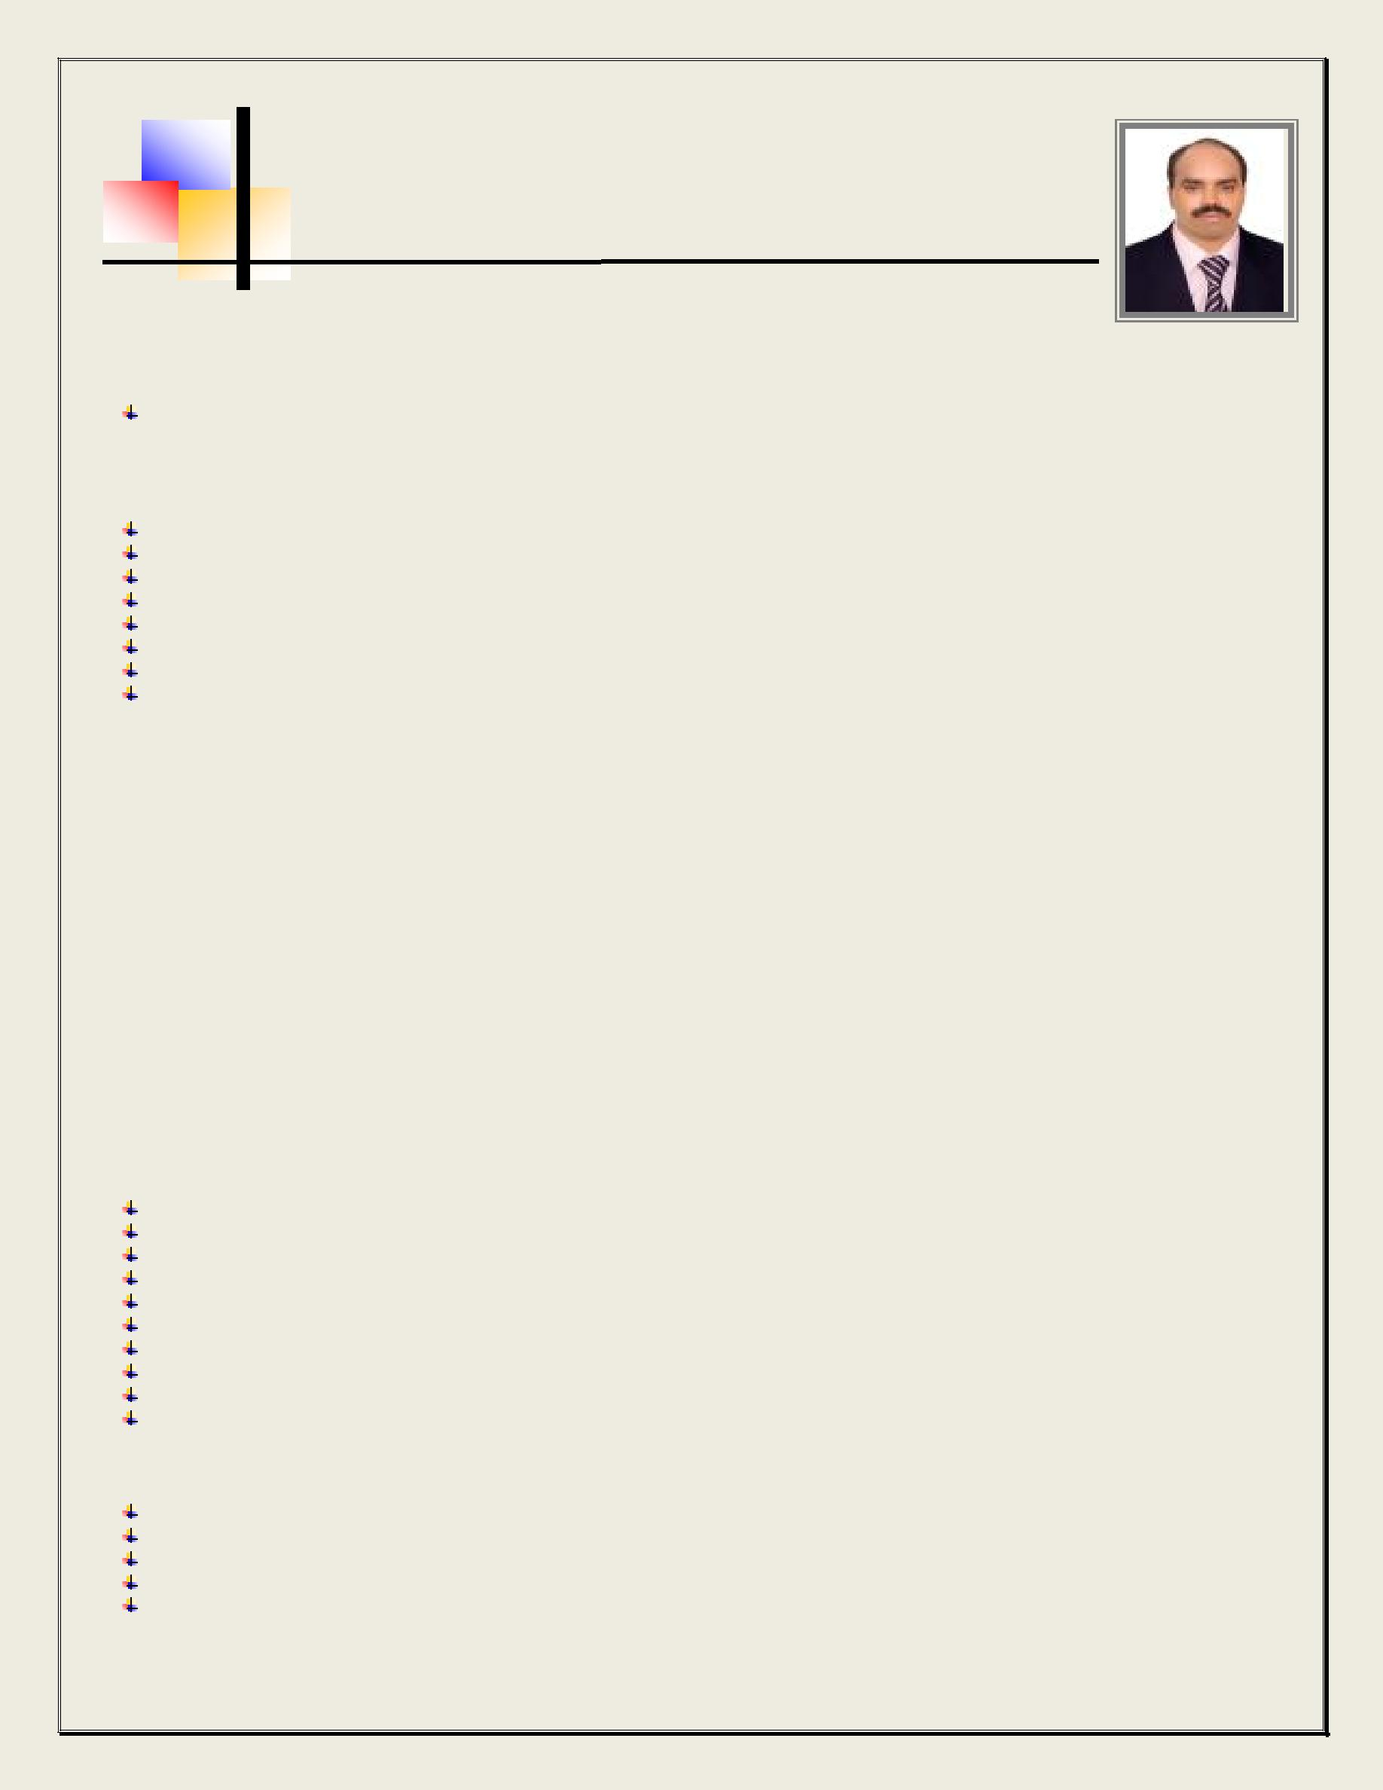
THOMAS

Email add: Thomas.374950@2freemail.com

CAREER OBJECTIVES:

Seeking an opportunity to work for an organization where I can fully utilize my present skills, develop new ones and contribute to the growth of the organization. To be committed to the success of any undertaking in an efficient and motivated manner.

CORE SKILLS:

With 8 years gulf experience.
Good standard of written and spoken English.

Flexible, adaptable and pro active
Can work under pressure.
Deal with people in a manner which shows sensitivity, tact and professionalism.
Maintains high standard of work.

Perform responsibilities under nominal supervision
Excellent command of computer applications MS office Outlook, Word , Excel

WORK HISTORY:

Position : Purchasing Officer
Company : FABTECH ABU DHABI L.L.C

Location : Abu Dhabi, United Arab Emirates
Year : November 2010 till February 2017

Position : Purchaser
Company : Perfect International (FZC)

Location : Sharjah, United Arab Emirates
Year : June 2008 to October 2010

Position : Purchase Assistant

Company : Nirmal Industrial Controls Pvt. Ltd
Location : Mumbai India
Year : April 2000 – May 2008.

Duties and Responsibilities:

Handling requirement from production
Arranging material from various suppliers.

Preparing comparison for the quotation received
Negotiate with supplier for rock bottom price.
Preparing purchase orders.(both local & International)

Coordinating with accounts department for invoices against each purchase order

Handling International Clients requirements.
Answering client’s quires.
Preparing day to day report.
Drafting mail and answering the received mails.

Transportation, Freight & Logistics

Arranging transportation to all GCC countries.

Arranging collection of import shipment from all over the globe.
Arranging documentation for clearing the shipment.
Daily arrangement for local and international freight.
Daily reporting the status to the Management.

Curriculum Vitae of Thomas
Page | 1

THOMAS

Email add: Thomas.374950@2freemail.com

TECHNICAL SKILLS:

Knowledge of Database. (MS Access)
Operating System: Windows 2000, Windows XP, Windows Vista, MS Dos

Having the knowledge of hardware & software.
Fax, Photo copy, Internet and Email

EDUCATIONAL BACKGROUND:

Undergraduate (PURSUING GRADUATION BCOM MUMBAI UNIVERSITY)
Extra Qualification: Course in International Purchase & supply Chain Manager (IPSCM) from Blue Ocean Academy (Dubai)

PERSONAL DATA:
Date of Birth | : | 27th December 1973
Birth Place | : | India
Civil Status | : | Married
Religion | : | Christian
Nationality | : | Indian
Passport Details | :
 |  | Date of Issue: 03/03/2008
 |  | Date of expiry: 02/03/2018
Visa Status | : | Visit Visa ( Long Term 3 months)

CHARACTER REFERENCE:

Available upon request.

I hereby certify that the above information are true and correct to the best of my knowledge and belief.

Thomas
Applicant

Curriculum Vitae of Thomas
Page | 2

