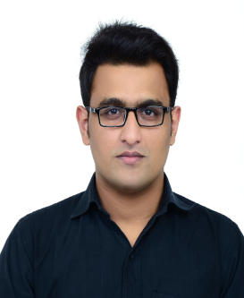
Kamran
kamran.374959@2freemail.com
Professional Summary
My goal is to become the point person for Hotel Industry , utilizing and building upon my skills in Marketing, sales, retail, and operating by continuously contributing to the company and seeking out professional development.
Skills
Excellent problem-solving and critical thinking abilities
- Good administrative abilities
- Good written and verbal communication skills
- Strong supervisory and leadership skills
- Solid understanding of guest relations and customer service within the hotel industry
- Terrific interpersonal and social skills
- Strong understanding of all aspects of hotel management
- Ensures hotel staff follow excellent guest care standards
- Good ability to analyze budgets for hotel departments and restaurants
Languages
English Advanced Level
Spanish Conversational Level
Education
Advanced Cth diploma In Hospitality And tourism Management
COTHM (College of Tourism & Hotel Management) Islamabad
Intermediate In Computer Science
Rawalpindi College of Commerce Rawalpindi
Certifications
Internship From Marriott International Hotel Islamabad
OPERA certification
Work History
January 2017 – April 2017
Internship at Islamabad Marriott Hotel in various Departments
April 2013 to Sept 2013
Sales Agent at Werstern Union San Pedro de Alcantara Marbella Spaim
April 2014 To August 2015
Sales Agent at MoneyGram Marbella Andalucia
June 2015 to October 2015
As a PR at Pappa rotti Restruant Port Banus Marbella Spain
May 2017 to August 2017
Worked As a Guest Relation Officer at Grand Regency Hotel Islamabad

