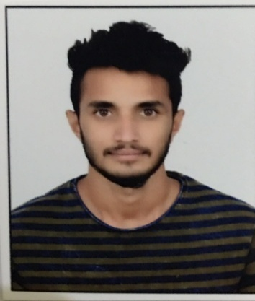
CURRICULAM VITAE

SUFIYAN
E-mail: sufiyan.374961@2freemail.com

CAREER OBJECTIVES

- A Sales / Customers Service position.
- To associate myself with an organization where there is an opportunity to share, contribute and upgrade my knowledge for development of self and organization served.
- Excellent communication and interpersonal skills, with ability to develop cohesion in group through team work and resourceful ideas

PROFESSIONAL EXPERIENCE

IKEA (SAMSUNG TELECOM) - (Bangalore, India) (June 2015 to Aug 2017)

Designation: Customer Service representative

Responsibilities:

- Opening and maintaining customer accounts by recording account information
- Resolving product or service problems by clarifying the customer's complaint; determining the cause of the problem; selecting and explaining the best solution to solve the problem; expediting correction or adjustment; following up to ensure resolution
- Maintaining financial accounts by processing customer adjustments
- Recommending potential products or services to management by collecting customer information and analyzing customer needs
- Preparing product or service reports by collecting and analyzing customer information
- Contributing to team effort by accomplishing related results as needed
- Managing large amounts of incoming calls
- Identifying and assess customers’ needs to achieve satisfaction
- Providing accurate, valid and complete information by using the right methods/tools
- Handling complaints, provide appropriate solutions and alternatives within the time limits and follow up to ensure
resolution
- Keeping records of customer interactions, process customer accounts and file documents
- Following communication procedures, guidelines and policies
- Go the extra mile to engage customers
- Resolve customer complaints via phone, email, mail or social media
- Use telephones to reach out to customers and verify account information
- Recommending potential products or services to management by collecting customer information and analyzing customer needs

QUALIFICATION

- Passed B.COM from Bangalore University, India WITH aggregate of 50.56%
- Passed PUC from Pre -University, Bangalore India

STRENGTHS

- Ability to work hard efficiently.
- Prompt and honesty till task completion.
- Good and obedient team player.
- Willing to learn new technologies.

COMPUTER PROFICCIENCY

- Basic Knowledge MS – Office
- Windows Operating system
- Photoshop
- Auto cad

PERSONAL PROFILE

Name : Sufiyan
Date of birth : 17th -Aug-1996
Gender : Male
Nationality : Indian
Languages Known : Hindi, English, and Kannada.
Marital Status : Single

PASSPORT DETAILS

Expiry date : 14/062026

VISA DETAILS

Current Visa : VISIT VISA
Visa Expiry date : 20TH Jan 2018

DECLARATION

I hereby declare that the above information furnished is true to the best of my knowledge and belief.

Place : DUBAI Yours’s Sincere,
Date : (Suffiyan)

