LOOKING FOR I&C
ENGINEER / BMS
ENGINEER

VISIT VISA : 2/JAN/18
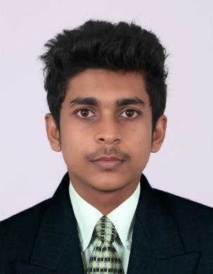

OBJECTIVE
Looking for an opportunity to work in an institution which provides professional development,interesting experiences and personal growth. I am a skilled professional in the field of Installation & Commissioning and BMS

SKILLS
- Networking

- Computer Assembling & Installation

- Electrical Wiring and Plumbing

RAZIF
Email: razif.374964@2freemail.com

EXPERIENCE
RF- ENGINEER

VIHANTA SMART POWER TECHNOLOGIES PVT LTD April 2017 – October 2017

- Installation & commissioning of BMS Projects and Jio (SAMSUNG) projects

- Drive Test of Jio (XCAL)

- Environmental Alarm Extension

- Alarm clearing

- Planning and Executing Microwave link Project

I&C ENGINEER / BMS ENGINEER

RS SPECTRA TECHNICAL SOLUTIONS PVT LTD

May 2015 – April 2017

- Maintenance and controlling of integrated building management sysyems

- CCTV – Operating and monitoring

- Access control systems

- Fire detection and Alarm systems

- PLC, SCADA, VFDs

- HVAC

- Drive Test of Airtel and Jio (TEMS ,XCAL)

- Installation and Commissioning of Airtel, Idea(NOKIA) 2G,3G,4G projects

- Planning and Executing Airtel BMS projects

- Surveying of the Idea and Airtel project

- Installation & Commissioning BTS

- Installation & commissioning of Vodafone (HUAWEI)

CERTIFIED BMS ENGINEER
Ingenious Power & Control Systems Pvt. Ltd.Cochin (IPCS)

- C-programing , Assembly level 8085/8086

- Subjects of interest : Electronic Devices and Circuits, Telecommunication, Mathematics

- MS Office, Proteus, Adobe Photoshop (Basic)

- Windows XP, Windows 7, Windows 8.1, Windows 10, Linux

PERSONAL PROFILE

Date of birth | :16 jan 1994
Gender | :male
Nationality | :Indian
Languages

known:Engish,Hindi,Malayalam

,Arabic
CCTV, PLC, SCADA, HMI, VFD, Access Controls, Security Systems,Controls & panels

EDUCATION
ELECTRONICS AND COMMUNICATION ENGINEERING (BTECH)

Cochin University of Science and Technology(CUSAT) 2011-2015

HIGHER SECONDARY

HSC State Board

VOLUNTEER EXPERIENCE OR LEADERSHIP
PROJECT : AUTOMATIC CAR PARKING SYSTEM WITH PLC

- Coded the program in RS Linx.

- Implemented the model in SCADA.

LEADERSHIP SKILL

Led a team of 15 students conducting ELECTRONICS EVENTS as a part of ZEALOUS 2K14, a national level technical festival at College of Engineering, Cherthala which was regarded as the best in the history of College.

FOOTBALL

Played in college team, school team, many clubs etc and has lead my team to success.

