RESUME
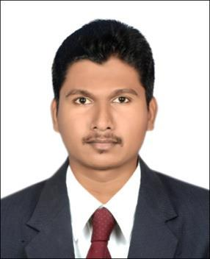

PERSONAL DETAILS:

Name | : | CHINDU .
Date of Birth | : | 04/APRIL/1992
Nationality | : | Indian
Religion | : | Hindu
Marital Status | : | Single
Computer Knowledge | : | AutoCAD 2d, Ms Office, Excel,
 |  | Photoshop & Internet,
 |  | SketchUp
Visa Status | : | Visit Visa
Email | : | Chindu.374972@2freemail.com

OBJECTIVES

Seeking a challenging career with a progressive organization where my academic background and experience will enable me to make a significant contribution to work allowing me utilize skills acquired my education and exceptional career.

EDUCATIONAL QUALIFICATION

High School Completed by Kerala Board of Education, Kerala, India. Secondary School Leaving Certificate by Kerala Board of Education, Kerala, India.

Draughtsman Civil with AutoCAD (2d, 3d, 3ds max) of Kerala, India AutoCAD 2d, 3d, 3ds max of CADD CENTRE, Kerala, India

Micro Station of CADD CENTRE, Kerala, India

Passport Details

Date of Issue | : | 06/02/2013
Date of Expiry | : | 05/02/2023

STRENGTH

Well Developed Communication Skills with good Customer relationship, Dedicated, Energetic, Can meet Tight Dead Lines.

JOB DESCRIPTION

- Reviewing information for completeness and accuracy.

- Checks plans.

- Transform AUTOCAD drawings into 3D drawings (If required).

- Prepare assembly and detail drawings on the basis of the information and instruction provided.

- Makes necessary calculations for drawing development.

- Prepares and assists in drawing revisions are required

WORK EXPERIENCE:

- From 2013 to 2016 working as a Draughtsman at GULF ECO FRIENDLY SERVICES FZC, SHARJAH, UAE

(3 years working experience)

- From 20 August 2016 to 23 October 2017 working as Draughtsman at GREENWALL CONSTRUCTIONS, KERALA, INDIA

LANGUAGES KNOWN

English, Hindi, Malayalam, Tamil, Urdu.

DECLARATION

I hereby declare that all the above mentioned statements are true and correct to the best of my knowledge and belie

CHINDU

