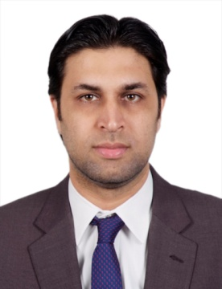
Faisal
UAE
E-MAIL faisal.374976@2freemail.com

PROFILE
A well presented, polite, tactful and friendly individual who is able to combine a polite manner with razor sharp efficiency. Able to do more than just answering questions, also has a proven track record of building relationships by providing information on additional products and services and helping customers find the right ones to meet their needs. Processing a excellent telephone manner and the ability to communicate with all levels of customers, able to contribute to the growth of any business.
SKILLS Product Knowledge Target Driven Up selling/Cross selling
Customer Service Communication Team Leader
Client co-ordination Sales Oriented Resolving problems
EXPERIENCE Noon Express, Dubai UAE.
Customer Service Representative
Feb 2017 – Jul 2017

Duties & Responsibilities to:
- Taking ownership for queries from first contact to resolution.
- Processing orders, forms, applications and requests for information.
- Interacting directly with potential, new and existing clients.
- Development, maintenance and retention of customer relationships.
- Accurately updating administrative records.
- Promoting products and services.
- Resolving face to face, telephone and email queries quickly and to completion.
- Implementing agreed promotional activities.
- Monitoring until completion outstanding orders and enquiries.
- Processing customer registrations.

Maxima Capital, Dubai UAE.
Relationship Officer
Sep 2016 – Feb 2017

Duties & Responsibilities to:
- Identifying potential customers and sell products and services to increase customer base.
- Handling daily individual day to day activities of sales.
- Maintaining good customer relations.
- Retaining the best services and products to the customers.
- Selling additional services by recognizing opportunities to up-sell, explaining new features and benefits.
- Determining requirements by working with customers.

Waheed Entrepreneurs, Pakistan
Sales Executive
Dec 2012 – Jun 2016
Duties & Responsibilities to:
- Identify prospective clients in the assigned region and prepare client data base while verifying contact details.
- Meet clients and conduct product demonstrations while explaining the benefits of the product over other brands.
- Communicate with existing clients to resolve their queries and problems and to generate new leads.
- Prepare sales and collection reports and presentations to discuss progress/regress in collection revenue.
- Developed database with the regional sales manager.
- Generated leads from the existing clients and converted all leads into clients by offering customized solutions.
- Retained clients who were unsatisfied by the services and offered them compensatory package while resolving issues related to service malfunctioning.
- Prepared periodic reports and presented those during team meetings.

Awan Dyeing House Pvt Ltd, Pakistan.
Sales & Marketing Representative
Sep 2010 – Nov 2012
EDUCATION Bachelor of Arts
University of Punjab

