ROSMY
ROSMY.374990@2freemail.com

MBA (Human Resource Management and Finance)

To join a growing organization that offers challenges and opportunities to grow with the company, where goals and objectives are clearly established and tools to reach such goals are provided.

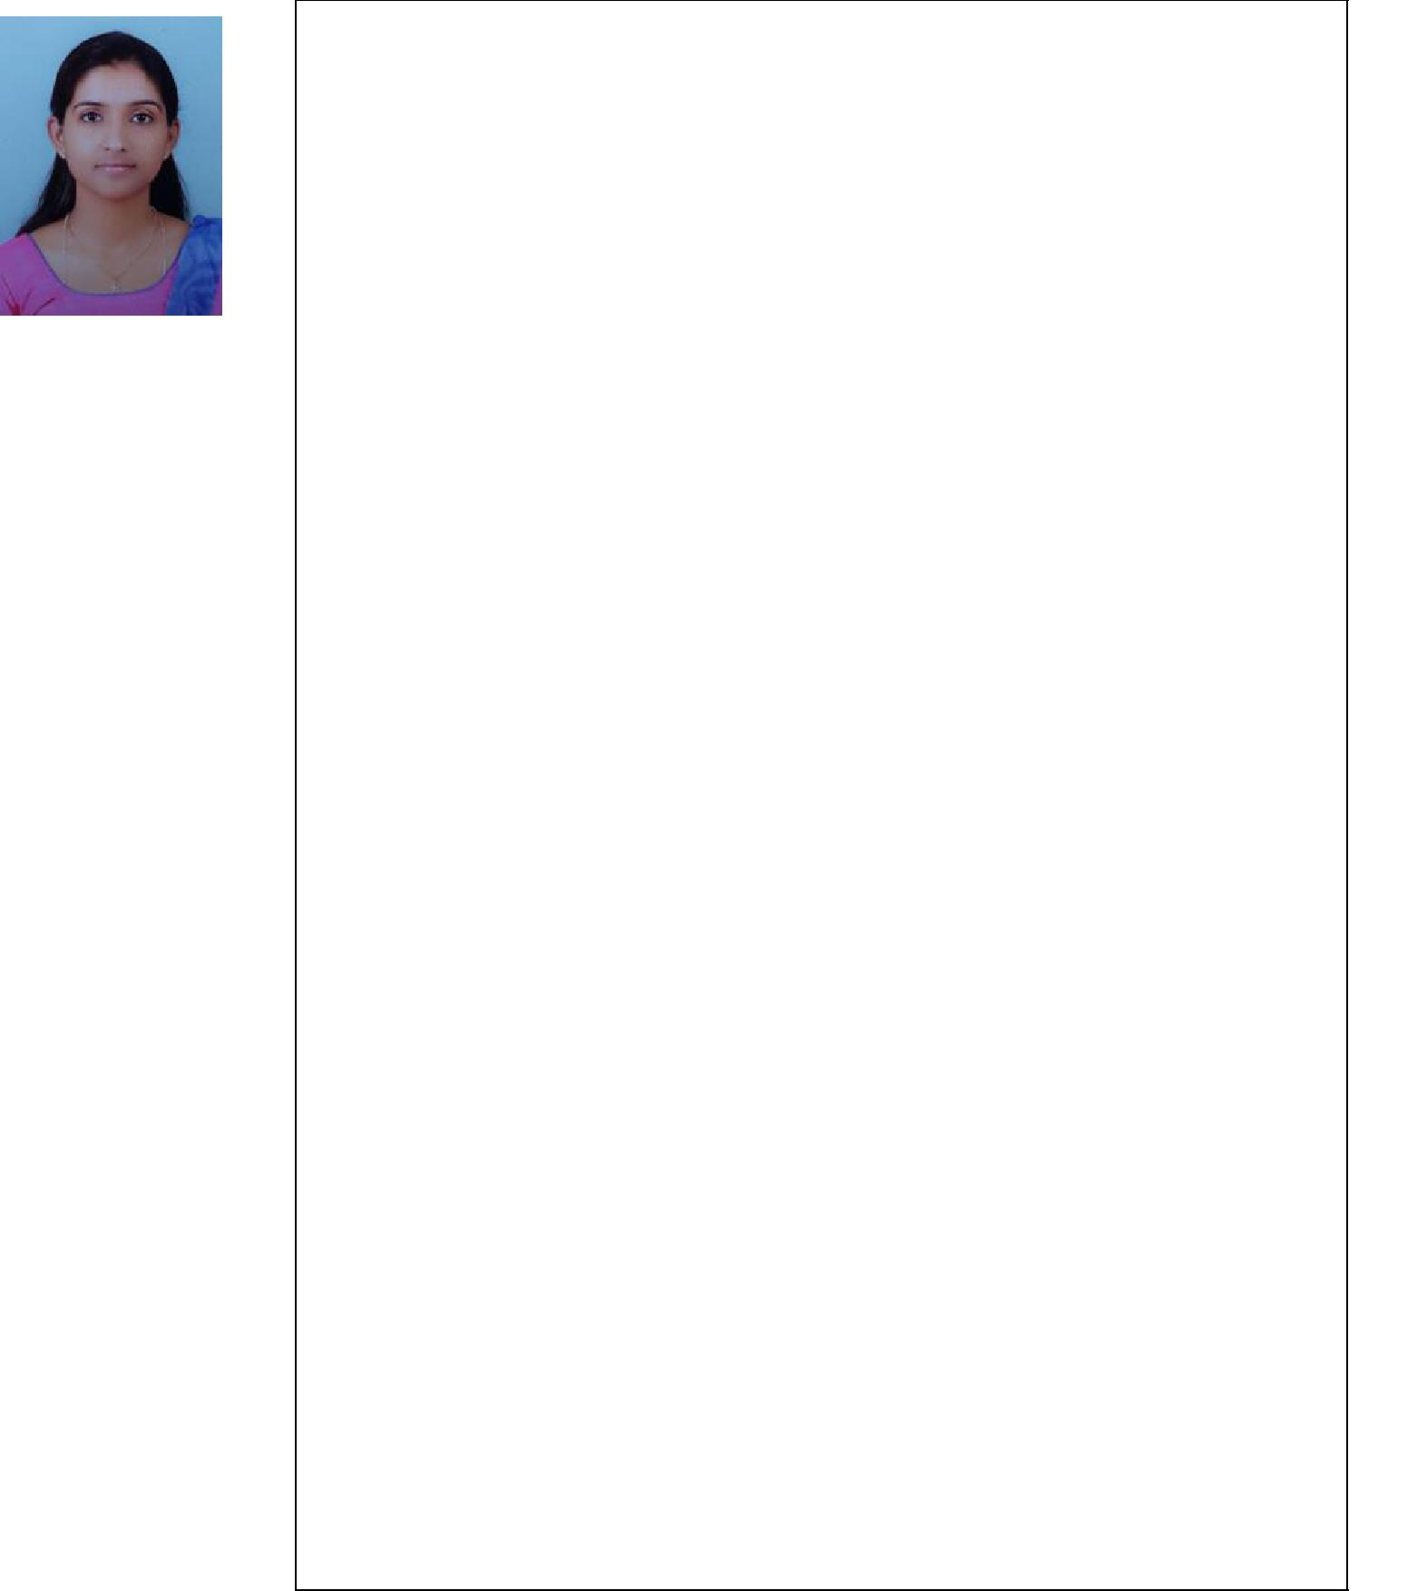

Date of Birth:

13-09-1993

Passport No:

Expires on 14-9-2027

Education

2014-2016 - Mahatma Gandhi University Kottayam, Kerala, India

- Master’s degree in Business Administration

- Specialized in Human Resource Management and Finance

- College topper

- Best outgoing student

- First class with 73%

2011-2014 - University of Calicut

- Bachelor’s degree in business Administration

- Specialized in Financial Management

- Successfully completed with 84%

Experience

2017 Jan to 2017 Sep

Executive Store (Administration and Sales Support)

Worked in Marikar Motors Ltd. Kerala’s first automobile dealers, I worked with their Royal Enfield Bullet Parts Division as ‘Executive store’ with 9 months experience in handling administration of warehouse activities, tracking and recording inbound and outbound movements of consignments. Handling some areas of HR activities; helps in recruitment, selection, and training. Performance appraisal, monitoring attendance and absenteeism of employees

Responsibilities:

- Preparing reports of warehouse activities

- Managing inbound and outbound activities

- Monitoring and reporting employee’s attendance and absenteeism

- Prepare and submit performance apprais to divisional manager

Page1

Strengths and Skills:

Good in Microsoft office tools

- Ability to deal with people at all levels

- Ability to work independently or as part of a team

- Leadership skills and ability to motivate

- Confident, sincere and hardworking personality

- A good level of patience

- Good level of listening and observation skills

Areas of Interest

Human resource management, training and development, banking and finance and marketing

Pre – Organizational Experience

- One month project work in HR department on the topic “level of motivation among employees” at Spinner pipes PVT LTD Thrissur

●One month organizational study at Vaidyaratnam Oushadhasala PVT LTD Thrissur

●Two months project work in HR department on the topic “effect of motivation on employee’s job performance” at Manjilas Food Tech PVT LTD Thrissur

Languages Known

- English
- Hindi
- Malayalam
- Tamil

Declaration

I hereby declare that all the information mentioned above is true to the best of my knowledge and belief.

Page2

