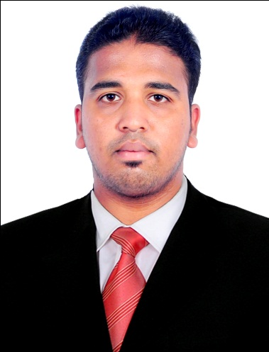 |  | ANANTHUKUMAR  Mechanical Engineer  Highly motivated and energetic Engineering professional with more than 2 year of experience in Power plant projects and Infrastructure; distinguished with a track record of superior academic results and working experience. A natural team leader and player with excellent communication skills and proven ability to work under extreme pressure and cross-cultural working environments.
PERSONAL DETAILS  E-mail: ananthukumar.375022@2freemail.com  DOB: 18 August 1992  Nationality: Indian  Language skills: English, Malayalam and Hindi  Address: Abu Dhabi, UAE  Date of issue :16 Sept 2015  Visa Status: Visit visa valid  till 24-Dec-2017  EDUCATION  Bachelor of Technology in Mechanical Engineering from Kerala University, India in 2015  Certification in QA/QC (ASNT NDT LEVEL II in UT, RT, MT ,PT) and Piping Engineering in 2015  ACHEIVEMENTS  Got appreciation for best safety concerned engineer from EHS department.  Have been complimented from L&T MHPS for best Project Execution Engineer.  Got appreciation from KFC (KeralaFinanceCoperation)for designing & manufacturing an Automatic Rubber sheeting machine  SOFTWARE PROFICIENCY  Basic knowledge in Auto Cad 2D and 3D, Solid Edge and  Fe-map  Microsoft Office, Project  INTERNSHIPS  Participate in KSEDM entrepreneur sumith-2014 conducted by Govt of Kerala  Training program in Autokast Ltd. Leading manufacturers and exporters  Vehicle body building and complete construction unit of  Prakash body construction company, Karnataka  Training program on ZWCAD conducted by College of Engineering and management punnapra |  | SKILLS  Strategic Planning Project Execution Leadership  Presentation skills Technical knowledge Creative  WORK HISTORY  PROJECt eNGINEER (Coordinatio,qa/qc,andExecution )  Bhavani Erectors Pvt Ltd, Raichur, India  June 2015 to September 2017  - 2x660mwsuper Critical Thermal Power Project Rajasthan Rajya Vidyut Utpadan Nigam Limited, Chhabra, Rajasthan  (Value: USD 50Million)  Client : RRVUNL Consultant : L&T  Duties :  - Complete Co-ordination of Boiler (Construction Erection Testing and Commissioning) activities from contractual stage to final light up.  - Progress meetings with Client, consultant and sub-contractors.  - Conducting internal progress meetings with Execution engineers and supervisors for project quality and on-time productivity.  - Responsible for material estimation, procurement ,MIV (Material Issue Voucher) preparation and also to raise indents regarding the materials needed for the execution of the project based on BOQ and to prepare the variation statement  - Follow ups on procurement and delivery of materials.  - Responsible for checking the completeness of the received materials, identification of any damaged/shortage of received materials and also to co-ordinate with the client for MRIR (Material Requisition & Inspection Report)  - Forecast, planning and execution of project as per the program and project completion time.  - On site and office reporting of project activities and progress.  - Proper tracking of subcontractors for completion of works at proposed time.  - Preparing Protocols Reports, RA Bills for each month’s and also the NCR (Non-Conformity Report) claim for that extra work.  - Held direct charge in Assembling, Erection and Alignment  - Ceiling Girder of 600MW Super Critical Boiler with netwt : 3000ton  - Four Intermediate block of boiler furnace with netwt : 250x4=1000ton  - Nose block of 660MW Super Critical Boiler with netwt: 750 ton  - Eco hopper with ring header, inlet manifold and Eco inlet header with netwt : 720ton  - Responsible for checking the alignment, quality of welded joints in Pressure Parts (Headers, Manifolds and Coils) piping and Duct works along with client.  - To check the HVAC drawings and do necessary coordinating and mentoring with the team members, supervisors and with other services on the time of boiler control unit construction.  - Review MEP contractor shop drawing prior to submittal for service co-ordination and ensuring that services provisions clearance is provided in time for structure.  - Analyzing the HVAC Drawings and oversee the installation work  - Manpower (350+) and machinery coordination and proper usage as per project requirements.  - Providing proper safety awareness through by joining the hands with EHS department.  2. 370mw Yelahanka Combined Cycle Power Plant, Yelahanka, Bengaluru, Karnataka  Client : KPCL Consultant: BHEL  Duties :  - All Engineering submissions and inspections prior to and during the project.  - Held supervision for skidding and erection of TG  - On site and office reporting of project activities and progress.

I hereby declare that all the above mentioned information is correct and true to the best of my knowledge and belief.

Abu Dhabi ANANTHUKUMAR

