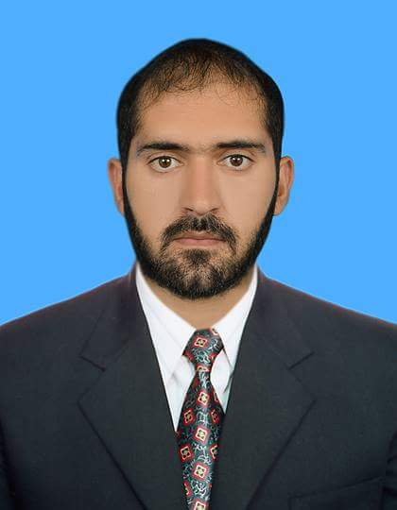
Nasrullah
Electronics & Communication Engineer

nasrullah.375031@2freemail.com

CAREER OBJECTIVES
To enhance my technical and interpersonal abilities by working in a professional environment where my knowledge and skills will be shared and enriched. To use my educational skills in the best possible way for achieving the Organization/Company’s goals.

PROFESSIONAL EXPERIENCE
Technical Support Engineer – PTCL Pakistan Telecommunication Co. LTD
12/2016-07/2017
Isamabad, Pakistan

Key responsibilities:
• Fault detection and rectification at main distribution frame- JPX-202/3219 (Huawei)
• Monitoring power supplies and cards etc at switch room
• Accountable for installation and coordination at site along with testing and commissioning landlines
• DSL installation and modem configuration.
• DSLAM configuration.
• Monitoring and data collecting from the local exchange.

OFC Engineer – PTCL Pakistan Telecommunication Co. LTD
12/2015-11/2016
Peshawar, Pakistan

Key responsibilities:
• Accountable for installation and coordination at site along with testing and commissioning of optical fibre cables.
• Fault detection and rectification at optical fibre –Splicing.
• MPLS, DXX, SDH, PDH.
• Staying attuned of latest technological advancements and utilizing the potential of the same to respond to the distinctive needs of the organization.
• OSN 3500 card installation.
• Operating, monitoring all the hardware panels in the optical fibre section

Trainee Engineer – PEDO , Malakand-III Hydro Power Plant Complex
01/2015-09/2015
Peshawar, Pakistan

Key responsibilities:
• Learned about the power generation process.
• Worked in the operation area, control section, switch yard, generator section, 4 bay, sediment excluder etc .
• Learned all basic info about hydro power generation and their distribution.
• Worked at the plant with total capacity of 81 MW .
• Hands on PLC and Scada control at the power plant.
• Took regular classes with the employ engineers regularly..
• Worked at the plant with total capacity of 81 MW .
• Examining the the Start up & stop of the turbines.
• Collecting data from the control room-Switch yard,CCR.
• Examining the the Start up & stop of the turbine.

EDUCATION
• CECOS University of IT and Emerging Sciences, Peshawar, Pakistan 2015
Bachelor's Degree
BS.(Hons) in Electronics & Communication

• BTE Peshawar, Pakistan 2011
Diploma of Associate Engineer
DAE. in Electronics Technology

PROJECT
• Graduation Final Year Project 2015 “Automatic Bidirectional Visitors Monitoring System”

PROFESSIONAL SKILLS
• Operating Systems : Windows XP, 7, 8, 10 (Installation & Maintenance)
• Circuit drawing : Hardware Discription Language(Verilog)
• Utility softwares : Adobe Photoshop, Ms Word, Ms Powerpoint
• Design softwares : Autocad
• OtherSoftware : LabView
• Computer : Hardware/Software

KEY SKILLS
• Willingness to learn • Adaptive to any working environment
• Optimistic and Hardworking • Comprehensive problem solving abilities
• Good team player • Leadership quality

PERSONAL INFORMATION
• DOB : 19, August 1991
• Gender : Male
• Nationality : Pakistan
• Visa Status : Tourist Visa (Transferable)
• Marital Status : Single

LANGUAGES
• English
• Urdu

AREAS OF INTEREST
• Telecom Sector • Industrial Automation • Digital Electronics
• Industrial Electronics • Electrical Power
• Robotics • Oil & Gas

