Objective
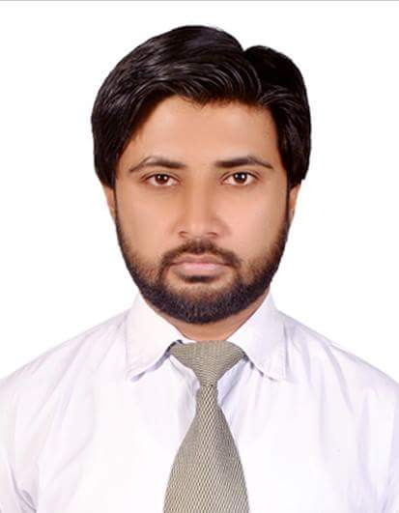
CURRICULUM VITAE
Faizan
Email: faizan.375046@2freemail.com
Visa status: Visit visa
To work in a friendly environment and have the ability to work as individual and also with the team and aim of providing best services.

PROFESSIONAL WORK EXPERIENCE
Ideas By Gul Ahmed
Duration: August 2016 – September 2017
Designations: Sales Executive
Location: Hyderabad - Pakistan
Responsibilities:
    - To give good greeting to the Customers
    - To listen their need or requirement
    - introducing new collection, designs and offers
    - Maintaining an orderly appearance throughout the sales floor
    - Achieving established goals and try to best effort

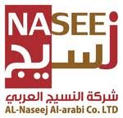
Al-Nasseej Al-Arabi (Pvt Ltd)
Duration: July 2014 – June 2016
Designations: Sales Executive
Location: Jeddah – Saudi Arabia
Responsibilities:
    - Provide high quality customer service to schedule appointments walk-in traffic
    - Conduct daily follow-up on outstanding quotes
    - Create a strategic Sales plan
    - Follow up on leads to generate new business
    - Contact vendors and shippers to track orders for customers ensure quality service
    - Continually develop sales skills product knowledge

Ibex Global >Telenor Call Centre
Duration: May 2013 – May 2014
Designations: Customer Service Officer Location: Karachi – Pakistan
Responsibilities:
    - To give good greeting to the Customers
    - To listen their Problem or need
    - To understand their Queries then solve the Problem
    - Make sure that they satisfied to our service or not
    - In last brief them our new service and get encourage to activate

Seats Furniture showroom
Duration: 11thMay 2012 – 30 April 2013
Designations: Sales Executive
Location: Karachi - Pakistan
Responsibilities:
- First get welcome to customer in showroom
- Brief to Customer about the all Products and offers
- Establish, develop and maintain positive business and customer relationships
- Try best to sell any Product if they don’t interested to purchase

Academic Qualification
- B.Com (Pass) :Passed in the year 2009 from University of Sindh.

- H.S.C (Eng.) : Passed in the year 2006 from B.I.S.E Hyd.

- S.S.C (Science) : Passed in the year 2003 from B.I.S.E Hyd.

Communication skills
- English
- Arabic
- Hindi and Urdu

CERTIFICATION/ ADDITIONAL SKILLS
- Windows XP
- MS Office 20013
- Internet & Email Etiquettes

PERSONAL INFORMATION
Date of birth: 24-09-1987
Religion : Islam
Nationality: Pakistani
Marital status: Single
Visa Status: Visit Visa (started from: 27 Oct-2017 to 27 Jan-2018)

