SAJEEV

Email: sajeev.375051@2freemail.com

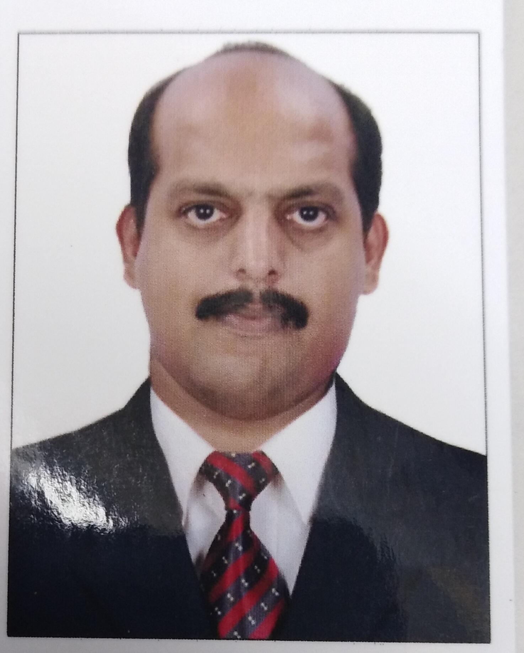
About Me
Age
39 Years

Date of Birth:
16-01-1978

Marital Status:
Married

Languages Known:
English
Hindi
Malayalam
Tamil
Arabic (Basic)

Academic Record
Bachelor of Commerce

Personal Summary

Dedication and the ability to learn best characterizes my work ethics. Organization, Communication and leadership are all the skills I have occurred during my previous positions. These capabilities distinguish me as a long term asset to your company, given the opportunity.

Work Experience

- HR OFFICER
Bayan National Construction Company. Kuwait
(Engineering, Construction and Design, Civil Contracting)
27th September 2014 to 06th August 2017

Job Responsibilities

- Responsible for hiring, developing and looking after employees
- Training and Monitoring the performance of employees
- Negotiating salaries, contracts etc with employees/agencies.
- Take care of safety and wellness of all the employees
- Preparation of joining forms, advance to release from accounts and handover passport to Admin and passport copies to new arrivals.
- Introduction of new joiners to concerned HOD’s /General Manager as required and forwarding the joining forms to HOD’s/General Manager for approval.
- Leave settlement process
- Resignation/Termination process
- Instruct the Vehicle department to make necessary arrangements for dropping at the airport and collect Passport & Exit form from Admin to handover to the employee with their signature collected through the Camp Boss.
- Maintaining employee details with time to time expenses to be entered in the log book

Technical Skills
Ms Office (Word, Excel, Power Point, Typing Skills in English…Etc)

Date of Expiry
08-04-2027

Skype id
Sajeev.menon6

- Take care of Staff issues which Includes departmental / accommodation / transportation issues and Complaints.
- Maintain Vehicle Maintenance/Repair and Fuel Expense Log book.

2 Front Office Supervisor cum HR & ADMIN Assistant
Sheikh Jassem Althani and Partners WLL. Qatar
(Consumer Services Company- Upvc, Aluminium, Steel and Glass works)
14th July 2012 - 19th July 2014

Front Office related job responsibilities

- Supervising Front Office team members
- Ensure outstanding customer service
- Courteously and accurately answers inquiries
- Responds to telephone and in-person inquiries
- Build strong relationships and liaise with all other department's
- Document Processing
- administrative support
- crucial situations handling skills

Admin related Job Responsibilities

- Visa & Work permit Renewal.
- Passport & License Renewals
- Qatar ID Process.
- Insurance Card Process
- Workmen compensation issues
- Employee welfare activities, Training sessions & Grievances.
- Facilitating & supporting who are sick and hospitalized within the prescribed policy.
- Timely updating and coordination in relation to accident cases and insurance related matters with the concerned departments.
- As per line manager instruction Organize & coordinate events.

HR related Job Responsibilities

- Approach with job portals/candidates & conducting interviews/initial screening the candidates/helping in recruitment process.
- Conducting Annual appraisal and evaluating the performance of employee for SALARY REVIEW.
- Records maintain & monitor attendance to ensure employee punctuality for absenteeism.
- Conduct exit interviews, Internal Transfers, Retentions for employees and record them accordingly.
KNOWLEDGE, SKILLS AND ABILITIES

- Considerable knowledge of mechanical, carpentry, building construction, and electrical skills.

- Ability to supervise the work of others.

- Ability to maintain financial records.

- Ability to operate and maintain grounds equipment.

- Ability to work independently.

Key Competencies & Skill :

- Business management.
- Guest/Customer satisfaction.
- Event management.
- Document controlling.
- Cost control
.Maintaining /updating leave records (Annual & Emergency)
- Identify training and development opportunities.
- New comers joining formalities
- Maintain all personnel files & update the employee database
- Take care of Staff issues which Includes departmental / accommodation / transportation issues and Complaints.

- Front Office and Housekeeping Executive
Edassery Group of Hotels & Resorts – 3 Star Resort
2nd November 2005 to – 1st July 2012

- Housekeeping Supervisor
ABAD Group of Hotels & Resorts – 4 Star Hotel
5th June 2003 – 4th September 2005

- Housemen
Gokulam Park Inn – 4 Star Business Hotel
1st October 2001 – 31st may 2003

Career work Summary(Hotels & Resorts in India)

- Responsible and accountable for complete cleanliness and Guest Satisfaction
- Monitor the property premises and carry out preventive maintenance periodically to ensure that company’s health and safety policies are adhered, housekeeping standard are met to create a safe and healthy environment for the Guests and the staffs
- Carry out inspection of accommodation, rooms, janitorial services, cleaning standards, housekeeping standards, food storage area and dining halls for staff cafeteria
- Formulate plans and establish work schedules for room maintenance Supervisors to ensure equal distribution of workloads, revise schedules as required.
- regularly inspect work being performed and ensure that standards are being met and
- Maintained.
- Make sure all the cleaning machineries are used properly and kept clean at the end of work like vacuum cleaners, scrubbing machines etc…
- Update the records on daily basis for the Housekeeping and Front Office operations
- Reports to the General Manager on a daily basis regarding the daily operations conducted and do the needful with his consent.
- Briefing and Allocation of duties for the staffs
- conducting a routine checking of all the Guest and Staff areas frequently
- Preparing of monthly inventory reports and responsible for all the fixed assets of the
- property in guest rooms and staff accommodation
- Managing all incoming and outgoing business calls and emails from the Front Desk
- Coordinate emergency response activities, like fire teams, medical teams and transport.
- Coordination with all departments for assistance and services as required.
- Receive visitors and guide them
- Maintain Registers regarding Front Office activities( check ins & check outs, maintain a record of guest requests & calls)
- Attend, Answer & transfer telephone calls and messages to concerned persons/departments
- Maintaining Lost & Found items as per company rules.
- Training of new recruits.

I hereby ascertain that the above details furnished are true to the best of my knowledge

DATE: 01/12/2017 SAJEEV

