CURRICULUM VITAE

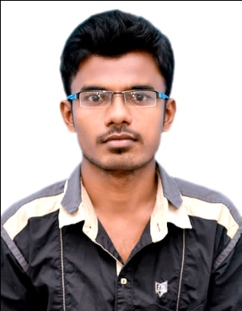
ALAUDEEN
Email: alaudeen.375055@2freemail.com
Deira,Dubai
Visa Status :Long Term Visit Visa [ Till 21st Jan 2018]
Availability Of Joining : Immediate

Objective:
Motivated professional having ability to work in challenging role to accomplish the organisation goals by utilizing my technical knowledge and innovative ideas.
Work Experience:
I have more than Two years of working experience in Sun Engineering Pvt Ltd. as a Production Engineer cum AutoCad Draftsman which involves in Production and fabrication of Power Transmission Line Towers and Substation Structures for Tamilnadu Electricity Board.
Roles &Responsibilities:
- Production planning
- Man-Power Handling
- Drawing creation using Auto Cad
- Operation and Maintenance
- Quality assurance and control
- Dispatch
Computer knowledge:
- Auto Cad- 2010
- MS-word, MS-Excel & MS-PowerPoint
Academic Profile:
Degree | Major | Institution | Percentage | Month & Year of Passing
B.E | Mechanical Engineering | J.J college of Engg. & Technology | 68% | May 2015
H.S.C | Maths&  Computer science | Kalyanasundaram Higher secondary school, Thanjavur | 87.10% | March 2011
S.S.L.C | - | St.Joseph’s High school, Thiruvaiyaru | 90.60% | March 2009

Trainings Undergone:
- Undergone 2 months training in Auto Cad from CADD centre, Thanjavur.
- Undergone Industrial visit in Chettinad cements, Karur which helps me to understand the process involved in Cement Manufacturing.
Projects done at College:
- Completed myfinal year project in “EFFECTIVE RAW MILL TYRE PRE-HEATING SYSTEM” in Chettinadcements,Karur.This type of preheating system helps us to remove the tyre from raw mill in an effective manner.
- Completed a mini project in Design and Fabrication of “DOUBLE U TUBE HEAT EXCHANGER”. The new heat exchanger helps us to reduce the cooling time by increasing the surface area in comparison to the existing heat exchanger.
Personal Details:
Date of Birth : 29-03-1994
Languages known : English, Hindi, Tamil
Passport details :
Passport Number | Date of Issue | Date of Expiry | Place of Issue
 | 09-09-2015 | 08-09-2025 | Trichy

Declaration:
I hereby declare that the details furnished above are true and correct to the best of my knowledge.

Place: Deira, Dubai Yours Truly,
Alaudeen

